Ph.D. Thesis

Development and Evaluation of Mixed Reality Educational Applications

June, 2018

Graduate School of PaiChai University

Department of Game Multimedia Engineering

Xiaoyun Duan

Development and Evaluation of Mixed Reality Educational Applications

Supervisor: Soo Kyun Kim

June, 2018

Graduate School of PaiChai University

Department of Game Multimedia Engineering

Xiaoyun Duan

The undersigned have examined the dissertation entitle: "Development and Evaluation of Mixed Reality Educational Applications" presented by Xiaoyun Duan, a candidate for the degree of Ph.D. in Game Multimedia Engineering and hereby certify that in their judgment it is worthy of acceptance.



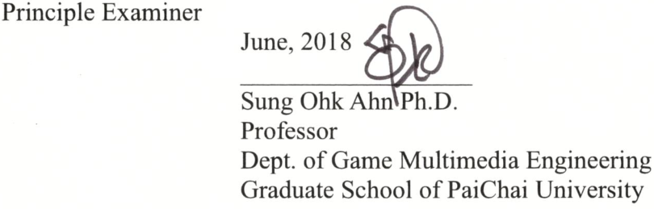

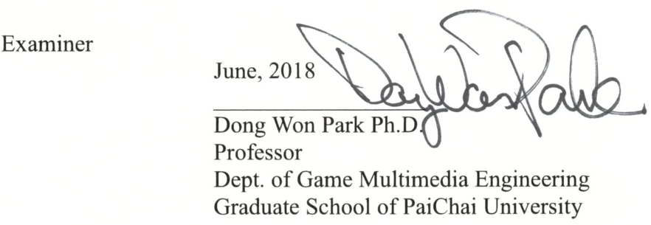

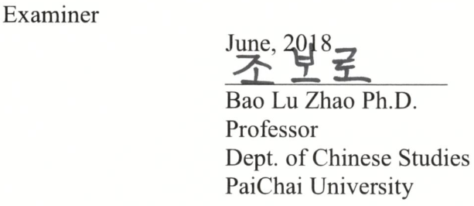

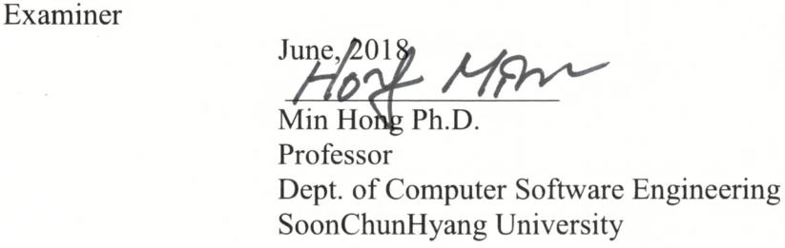

Development and Evaluation of Mixed Reality Educational Applications

Xiaoyun Duan

*Department of Game Multimedia Engineering*

*Graduate School of PaiChai University, Daejeon, Korea*

(Supervised by Professor Soo Kyun Kim)

How to complement the advantages of intelligent technology and traditional teaching methods is an issue that educational researchers and front-line education practitioners need to explore. Currently Virtual Reality(VR) and Augmented Reality(AR) have been applied in many fields. How to better apply it in educational teaching is the research purpose of this paper. VR technology and AR technology can promote students to transform from the passive acceptance process to learning in the independent experience process. Both technologies emphasize the simulation environment and user's personal experience and engagement. Mixed Reality(MR) combines the features of these two technologies.

This paper introduced in detail the core technologies of VR and AR and their application in education, elaborated the advantages of VR and AR in education compared to the traditional teaching model, designed and developed three AR and VR education practical cases, namely, VR art exhibition, AR 3D Coloring game and MR Chemistry Lab, and introduced the design and development process of each application in Chapter III, Chapter IV and Chapter V respectively. Finally, a scientific evaluation system was used to obtain the evaluation results of these applications in terms of educational effects, equipment characteristics, interaction control and user experience. Through the analysis of these evaluation results, the mode to combine MR with educational teaching and the basic principles for equipment selection and interaction design were summarized, thereby obtaining some experience and methods for applying AR and VR in educational design and development and providing useful reference materials for the application of VR technology and AR technology and the improvement of educational teaching quality.

**Keywords:** Virtual Reality; Augmented Reality; Mixed Reality; Educational Application; Game-based Learning Application.

# **Table of Contents**

Abstract i

Table of Contents ii

List of Figures v

List of Tables viii

I . Introduction 1

1.1 Concepts 2

1.1.1 Virtual Reality 3

1.1.2 Augmented Reality 6

1.1.3 Mixed Reality 13

1.1.4 Distinguish of VR and AR 16

1.2 Objectives and Scope 17

1.3 Contribution 17

1.3.1 VR Art Exhibition Application 18

1.3.2 AR 3D Coloring Game 18

1.3.3 MR Chemistry Lab Application 19

1.4 Dissertation structure 20

II . Related Work 21

2.1 Educational Applications Types 22

2.2 Interaction Design 35

2.2.1 The develop of HCI 35

2.2.2 Interaction Design for VR and AR 37

2.2.3 User Interface Design for VR and AR 39

III . VR Art Exhibition 41

3.1 Game Design 41

3.1.1 Composition of Contents 42

3.1.2 Immersion for VR Exhibition 43

3.1.3 Interaction Design and Operating Mode 45

3.2 Implementation 45

3.3 Conclusion 48

IV . AR 3D Coloring Game 49

4.1 Game Design 50

4.1.1 Color the Earth AR 50

4.1.2 Color Xi Xi AR 51

4.2 Implementation 52

4.2.1 Color the Earth AR 53

4.2.2 Color Xi Xi AR 67

4.3 Conclusion 69

V . MR Chemistry Lab 71

5.1 Game Design 72

5.1.1 Leap Motion 73

5.1.2 Oculus HMD 74

5.2 Experiment procedure 77

5.2.1 E1 using Leap Motion 78

5.2.2 E1 using Oculus HMD 78

5.3 Implementation 79

5.3.1 Leap Motion 79

5.3.1.2 Implementation Result using Leap Motion 83

5.3.2 Oculus HMD 85

5.3.2.2 Implementation Result using Oculus 88

5.4 Conclusion 89

VI . Evaluation 92

6.1 Evaluate System 94

6.1.1 Educational Game Evaluation Gauge 96

6.2 Evaluations for the 3 cases 100

6.2.1 VR Art Exhibition Evaluation 102

6.2.2 AR 3D Coloring Game Evaluation 104

6.2.3 MR Chemistry Lab Evaluation 108

VII . Conclusions 114

References 118

Korean abstract 125

Acknowledgement 126

# **List of Figures**

[[Figure 1-1] OculusWorldDemo Stereo Rendering 4](#_Toc515544286)

[[Figure 1-2] Three Mainstream VR Equipment 5](#_Toc515544287)

[[Figure 1-3] Google Tilt brush applications 6](#_Toc515544288)

[[Figure 1-4] HoloLens by Microsoft 7](#_Toc515544289)

[[Figure 1-5] Relation between marker and camera coordinate 9](#_Toc515544290)

[[Figure 1-6] Transformation matrix 9](#_Toc515544291)

[[Figure 1-7] Pokemon Go operation picture 13](#_Toc515544292)

[[Figure 1-8] IKEA Place application 13](#_Toc515544293)

[[Figure 1-9] Simplified representation of a “ virtuality continuum” 14](#_Toc515544294)

[[Figure 1-10] Venn diagram of the focus of the work 15](#_Toc515544295)

[[Figure 1-11] The distinguish of VR and AR. 17](#_Toc515544296)

[[Figure 1-12] Research flowchart 20](#_Toc515544297)

[[Figure 2-1] I Dinosaur 25](#_Toc517010166)

[[Figure 2-2] Physical magnetic field visualization 26](#_Toc517010167)

[[Figure 2-3] Simulated convex lens imaging 27](#_Toc517010168)

[[Figure 2-4] Chemical hydrogen peroxide 28](#_Toc517010169)

[[Figure 2-5] First person perspective of earth-sun AR exercise 29](#_Toc517010170)

[[Figure 2-6] World of Comenius – Use Leap Motion Interact with the Virtual human body with just hands 30](#_Toc517010171)

[[Figure 2-7] Interface of “AR school” English 31](#_Toc517010172)

[[Figure 2-8] Coqui ABC Immersive Children’s English Learning 32](#_Toc517010173)

[[Figure 2-9] Virtual Construction Site Program 33](#_Toc517010174)

[[Figure 2-10] Hyundai Engineering safe education Program 33](#_Toc517010175)

[[Figure 2-11] Chinese Zither Application 35](#_Toc517010176)

[[Figure 2-12] Flat Design User interface in Google tilt brush 40](#_Toc517010177)

[[Figure 3-1] Google Cardboard 42](#_Toc515283532)

[[Figure 3-2] Works of Art 43](#_Toc515283533)

[[Figure 3-3] Game Scenes 47](#_Toc515283534)

[[Figure 4-1] The playing flow chart of Color the Earth AR 51](#_Toc515283535)

[[Figure 4-2] The recognition pictures 52](#_Toc515283536)

[[Figure 4-3] The flowchart of coloring AR 53](#_Toc515283537)

[[Figure 4-4] The identification pictures 54](#_Toc515283538)

[[Figure 4-5] The recognition level of the picture 55](#_Toc515283539)

[[Figure 4-6] The viewing angles at the model 56](#_Toc515283540)

[[Figure 4-7] The invisible parts of the model 56](#_Toc515283541)

[[Figure 4-8] The UV coordinates and screen coordinates 57](#_Toc515283542)

[[Figure 4-9] UV matching of the tellurion model 59](#_Toc515283543)

[[Figure 4-10] Unity scene view 60](#_Toc515283544)

[[Figure 4-11] Screen coordinates 61](#_Toc515283545)

[[Figure 4-12] The relationship between the identification picture 62](#_Toc515283546)

[[Figure 4-13] The texture coordinate calculation 63](#_Toc515283547)

[[Figure 4-14] The world coordinates of the image vertices 64](#_Toc515283548)

[[Figure 4-15] The programming logic diagram 65](#_Toc515283549)

[[Figure 4-16] Game scenes 67](#_Toc515283550)

[[Figure 4-17] Two characters’ original sketch for recognition 68](#_Toc515283551)

[[Figure 4-18] The XiXi Model 68](#_Toc515283552)

[[Figure 4-19] The running screens of Color Xi Xi 69](#_Toc515283553)

[[Figure 5-1] The flowchart of MR Chemistry Lab 74](#_Toc515283554)

[[Figure 5-2] Main scene 75](#_Toc515283555)

[[Figure 5-3] Drag the element's atomic structure model to the front 76](#_Toc515283556)

[[Figure 5-4] ChemVR scene 77](#_Toc515283557)

[[Figure 5-5] The experiment desk 78](#_Toc515283558)

[[Figure 5-6] Hand control with Leap Motion 80](#_Toc515283559)

[[Figure 5-7] LeapHandController prafebs 81](#_Toc515283560)

[[Figure 5-8] Definition of hand gestures 82](#_Toc515283561)

[[Figure 5-9] Light the Alcohol fire by pointing 82](#_Toc515283562)

[[Figure 5-10] MR Chemistry Lab scenes 85](#_Toc515283563)

[[Figure 5-11] Oculus Hand Controllers 86](#_Toc515283564)

[[Figure 5-12] Chemistry lab experiment scenes 89](#_Toc515283565)

[Figure 6-1] VR art exhibition evaluation using Google cardboard and android phone 103

[Figure 6-2] The evaluation process pictures of the Coloring the Earth AR 106

[Figure 6-3] The evaluation process pictures of the MR Chemistry Lab 111

# **List of Tables**

[Table 3-1] Influencing Factors of Immersion in Virtual Reality Display 44

[Table 6-1] Educational advantages according to characteristics of virtual world 94

[Table 6-2] Five Steps for Digital Gamification Learning Environment Evaluation 95

[Table 6-3] Educational Game Evaluation Gauge Research 97

[Table 6-4] Gauge Dimension Design of Evaluation System in the Research 99

[Table 6-5] Education Purposes and Target Objects of Each Game in the Application 100

[Table 6-6] Experimental Subjects and Groups 102

[Table 6-7] The VR Art Exhibition Evaluation Result 104

[Table 6-8] The AR 3D Coloring Game Evaluation Result 107

[Table 6-9] The MR Chemistry Lab Evaluation Result 112

* + - 1. . Introduction

Ancient Chinese people advocate the education proposition that “it is better to travel ten thousand miles than to read ten thousand books”, which means that one who wants to attain achievements could never make it simply by reading. Reading harvests intelligence but travel harvests experiences. While such experiences could sublimate to intelligence more practical and more important than that learned from books. The intelligence of the ancients reminds people that knowledge and experience supplement each other in education. However, limited by the implementation conditions in reality, education oriented towards the public lays emphasis on reading but overlooks intuitional stimulus to sense organs and knowledge taught by experience and comprehension. Personal experience is of vital importance to education. However, under traditional education mode, due to the limitations in time and space, schools usually fail to provide enough experiential environment for students and it is extremely inconvenient to implement experiential teaching in practice. Whereas, along with the fast development of computer technology, high immersive game experience in the film “Ready Player One” (2018) might come true in the near future. Computer simulated reality represented by virtual reality technology and augmented reality technology could replace the “travel for ten thousand miles” and fill in the blank in this field. For instance, teachers could introduce local topography in geography class, introduce the living environment of local plants and animals in biology class, introduce the augmented microworld in real world and allow students to timely conduct experiments in chemistry class. More importantly, free from the restriction in time and space, this technology could be repeated adopted. While initiating a revolution to traditional education, it also brings about infinite development potentials.

In recent years, education game has become one research hotspot which resorts to technology to promote teaching. By utilizing network technology or intelligent instrument as the interactive medium to assist learning, improve learning participation degree and continuum, education game boosts the diversity of learning methods and the interactivity of learning process [1]. The researcher is devoted to the study on the promotion role of education game in learning from the perspective of teaching principles, learning activity design and technology application. How to maintain learners’ learning interests and improve learners’ learning effects is one of the great challenges confronted by education game research. How to make the advantages of intellectual technology and traditional teaching method complementary to each other has always been a problem to be explored by education researchers and front-line education practitioners. Research purpose of the thesis is exactly to figure out how to better apply the latest virtual reality and augmented reality technology in teaching.

This chapter presents a brief overview of the context under which the research was conducted. Background information regarding this study is provided in order to establish research objectives and scope. Then, the contributions are discussed. Finally, the structure of the dissertation is outlined.

* 1. 1.1 Concepts

Virtual Reality (abbreviated for VR) and Augmented Reality (abbreviated for AR) technology had been already proposed as early as the 1960s. In the early stage, the two technologies were classified into the development stage of frontier science. While Mixed Reality (abbreviated for MR) technology was raised by Ronald Azuma based on the development of AR and VR [2]. As the human-computer interface which realizes natural interaction among the virtual environments generated by human and computer, VR, AR and MR all have extensive application development prospects.

Prime application fields of VR and AR include: Industrial manufacturing and maintenance field which displays multiple auxiliary information to users via head-mounted displayer, including virtual meter panel, equipment interior structure and equipment parts drawing. Medical field which utilizes VR method to help doctors diagnose diseases, cure patients and train medical staff. Television replay field which supplements auxiliary information to replay scenes by virtue of AR technology. Entertainment and game field such as VR games, VR videos and films. Education field which realizes immersive teaching via VR. News field which realizes 3D words and pictures, and increases reading interactivity and interests via VR. Tourism and exhibition field which builds up digital scenic spots and exhibition and allows users to visit beautiful scenery of the world at home. For instance, municipal construction could take VR technology to supplement planning effects to real scenes and directly see the planning effects. The following sections will introduce VR and AR technology.

1.1.1 Virtual Reality

Virtual Reality Immerses a user in an imagined or replicated world (like video games, movies, or flight simulation) or simulates presence in the real world (like watching a sporting event live). The world of VR exists all the time. Comic books, games and fictions all belong to VR in traditional sense, but they are limited by the visual sense and auditory sense of mankind. Above all, they could not create immersive sense for users.

VR technology mainly refers to the three-dimensional VR based on head-mounted equipment. This technology could actualize kind of immersive 3D experiential effects by offering users different images of one object from two perspectives. In Figure 1-1(a) is Tuscany VR demo by the Oculus VR team(b) is Tuscany VR demo rendered in stereo for the Oculus Rift HMD.



(a) Tuscany VR demo by the Oculus VR team

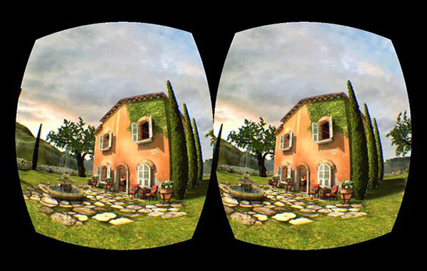

(b) Tuscany VR demo rendered in stereo for the Oculus Rift

Figure 1-1. Oculus World Demo Stereo Rendering [3]

VR based on head-mounted equipment could be divided into three categories, namely VR HMD + PC, VR HMD + Mobile and VR all in one. Typical examples of VR HMD + PC include Oculus Rift, HTC Vive and Vive Pro and Vive wireless adapters released by HTC as shown in Figure1-2(a). While the typical examples of HMD +Mobile include Samsung Gear VR and Cardboard glasses box issued by Google on I/O Conference in June 2014 as shown in Figure 1-2(b). In general, the glasses box is a kind of VR display equipment which places phone in VR Cardboard glasses box for watching. In spite of the relatively rough experience, such kind of equipment does not require any complicated electronic components nor high costs and meanwhile has high mobility and portability. VR all in one machine as shown in Figure1-2(c) integrates functional models such as display, computation, storage and power supply into the head-mounted display equipment. For having better performance, display equipment could be hardly made convenient and portable. For instance, Millet cooperated with Oculus to issue VR all in one machine Mi VR Standalone in 2017.

 

(a) HTC HMD [4] (b) Google Cardboard [5] (c) DaPeng All in one device [6]

Figure 1-2. Three Mainstream VR Equipment

The core technology of VR is Tracking and CG (computer graphic). In the latest technology of VR, Google Tilt brush which obtains digital craft award on Cannes International Festival of Creativity is a typical representative. As a VR drawing software issued by Google, Tilt brush enables users to draw in a 3D space by way of HTC VIVE’s HMD and control handle. Artists could create works in the 3D world with digital technology free from traditional 2D graph, which inevitably affects the creation way of the artistic field fundamentally. As shown in Figure 1-3(a), users could draw a 3D volcano in front of their eyes. This technology is applicable for the education field. In another example, mathematical teachers in senior high schools would try all means to help students understand that the graphs drawn on the plane blackboard is a 3D graph rather than a plane graph. The application of VR technology could present 3D graphs before students. For instance, the explanation process as shown in Figure 1-3(b) is more visual and interesting.

 

(a) Draw a Volcano in VR [7] (b) Teaching Math in VR [8]

Figure 1-3. Google Tilt brush applications

1.1.2 Augmented Reality

“Augmented” means improved or expanded or enhanced. Example of a general Augmented reality might be the ability to wear headphones that can allow you to hear sounds (higher or lower that the normal auditory spectrum). Augmented Reality overlays digital imagery onto the real world, Example of Hardware players on AR are Microsoft Hololens [9] and Google Glass [10]. They bring new ways to teach and learn. It is easier to show than to tell. With HoloNotes in Skype, friends and colleagues can help one with difficult tasks. Get real-time help from someone who sees what wearer see. Shown in Figure 1-4.



Figure 1-4. [HoloLens in Skype](http://link.zhihu.com/?target=https%3A//media.nngroup.com/media/editor/2016/09/18/hololens.jpg) [11]

In terms of technological means and patterns of manifestation, AR could be explicitly classified into two categories, namely Vision based AR (the computer vision-based AR) and LBS based AR (the geographical location information-based AR). The thesis will respectively explain the concepts and theories of the two categories in the following sections.

* **Vision based AR**

The computer vision-based AR makes use of computer vision method to establish the mapping relation between the real world and screen so that the graphs or 3D models to be drawn could appear on the screen like the attachment to real objects. How to make it come true? In essence, the procedure is to find an attachment plane in the real scene, map the 3D plane to the 2D screen and finally draw the desired graph on this plane. From the perspective of technical implementation means, it could be grouped into two categories.

1. Marker-Based AR

This kind of means of implementation takes a predetermined Marker (such as a template card painted with certain forms or QR code) and later places Marker in a real place like determining a plane in the real scene. The specific place of the Marker is found out through identification and pose estimation via the camera. The coordinate system which takes Marker as the original point is defined to be the Marker Coordinates, namely template coordinates. What people should do here is to derive a conversion and accordingly establish a mapping relation between template coordinates and screen coordinates. In this way, people could reach ideal graphic effects on the Marker by displaying graphs on the screen according to the conversion. To understand this principle needs a little bit knowledge about 3 mapping geometry. The conversion from template coordinates to real screen coordinates needs to firstly rotate horizontally to camera coordinates and later map camera coordinates to screen coordinates, shown in Figure 1-5, actually, as a result of hardware errors, this process also requires the conversion from ideal screen coordinates to real screen coordinates. This part of knowledge will not be introduced here. The AR 3D Coloring Game developed in this paper used Marker AR, details introduced in Chapter 3.

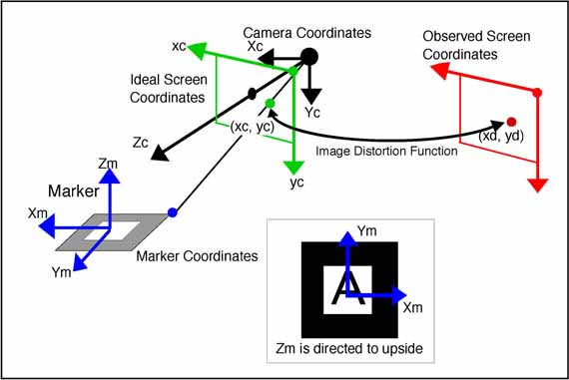

Figure 1-5. Relation between marker and camera coordinate [12]

In real coding process, all of these conversions are matrixes. In linear algebra, matrix symbolizes one conversion. Matrix pre-multiplication is actually a linear conversion (such non-linear conversion could have matrix operation with homogeneous coordinates). Here presents the formula.

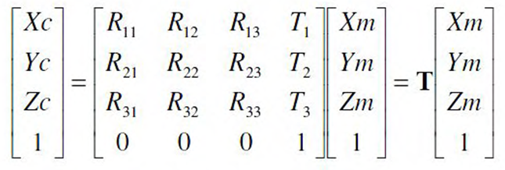

Figure 1-6. Transformation matrix [12]

The scientific term of Matrix C is camera interior parameter matrix and that of matrix Tm is camera exterior parameter matrix. The former is predetermined by camera calibration and the latter is unknown. Tm could be estimated pursuant to screen coordinates (Xc ,Yc), predetermined marker coordinates and interior parameter matrix. Graphic drawing demands the reference to Tm. For instance, in OpenGL drawing process, people need to load Tm matrix to display the graph under GL\_MODELVIEW mode.

1. Marker-Less AR

With a rationale identical to Marker based AR, it could take any object with enough feature points (such as book cover) as the plane benchmark but do not need any predetermined model. In this sense, it gets rid of the constraint of the template on AR application. Its rationale is to retrieve feature points of the template object through a series of algorithms (such as SURF, ORB and FERN) and meanwhile record or learn these feature points. The camera will retrieve the feature points of surrounding scenes while scanning surrounding scenes and compare with those recorded features points of template models. Once the scanned feature points and template feature point matching quantity exceed the threshold value, a conclusion could be drawn that the camera has scanned the template. Afterwards, Tm matrix could be estimated in combination with corresponding feature points coordinates and drawn out with a method similar to Marker-Based AR.

1. AR Kit and AR Core

On the WWDC Conference in 2017, Apple Inc. presented a brand-new augmented reality module AR Kit in iOS 11. This application is suitable for iPhone and iPad platforms. AR Kit, Apple's augmented reality (AR) technology, delivers immersive, engaging experiences that seamlessly blend virtual objects with the real world. In AR apps, the device's camera presents a live, onscreen view of the physical world. Three-dimensional virtual objects are superimposed over this view, creating the illusion that they actually exist. The user can reorient their device to explore the objects from different angles and, if appropriate for the experience, interact with objects using gestures and movement [13]. The upper part of iPhoneX has a sensor able to map to human eyes with invisible light and retrieve users’ facial 3D structure. In consequence, iPhone nerve engine instant processing data could build up facial model. This function actualizes Face ID and lovely Animoji. AR Kit employs visual inertia odometer (VIO) to track surrounding environment and discern its movement in the room in a high-precision manner. For instance, AR Measure Kit ruler application allows users to simply use iPhone to measure the precise size of objects and draw and measure the trajectory without any measurement instrument.

* **LBS-Based AR**

The rationale is to retrieve users’ geographical location via GPS, retrieve the POI information of surrounding objects near to certain data sources (such as restaurant, bank and school， and later retrieve users’ handheld device orientation and angle of inclination via mobile devices’ e-compass and acceleration sensor. Throughout such information, the plane benchmark (or say, the marker) of the target objects in real scene could be established with such information. Subsequent coordinate conversion display rationale is similar to that of Marker-Based AR.

Free from the reliance on Marker, the implementation of such AR technology requires equipment GPS function and sensor. It has better user experience than Marker-Based AR. Additionally, since it does not need to have real-time identification of Marker pose and calculate the features points, it has superior performance to Marker-Based AR and Marker-Less AR. Therefore, comparing with Marker-Based AR and Marker-Less AR, LBS-Based AR has better applicability in mobile equipment.

In January 2015, Google released Google Glass. In 2016, Nintendo mobile AR game Pokmon Go aroused a great sensation across the globe. As shown in Figure 1-7 [14], users could collect mobile virtual cartoon characters in the real world through phone camera. Augmented reality also starts to be open to common users. In respect of entertainment, AR photography application – FaceU enables users to add all sorts of cartoon images to their own photos in real time. In respect of military science, the concept of AR is firstly applied in military field and firstly proposed by Thomas Caudell and David Mizell [15]. The military application is also an important momentum to propel the development of augmented reality. Supported by AR technology, pilots do not need to lower their heads to see the instrument but could read out the state of the plane on HUD head-up display, including course, speed, and information of the enemy plane provided by fire control radar. Similarly, parking assistance system does not require users to provide any additional information or directives because it could actively offer available information based on the current state of vehicles and the relative location of surrounding obstacles. Google Translate application translates the written messages in some areas of the real world into another language by virtue of mobile phone. All of these belong to the application cases of AR.



Figure 1-7. [Pokemon Go operation pictures [1](http://link.zhihu.com/?target=https%3A//media.nngroup.com/media/editor/2016/09/18/pokemon-go-ar.jpg)4]

Likewise, another new application program of IKEA could help users see the real scene of some household products at their home or in the office via AR technology. This application program shows in Figure 1-8, has been applied in over 2000 IKEA products.

 

Figure 1-8. IKEA Place application [16]

1.1.3 Mixed Reality

Here are two kinds of explanations for MR. Mixed Reality, is also referred to as naked eye reality + virtual scene. A typical example is Magic Leap in 2015 maps virtual environment to the real environment. Mediated Reality is digital reality + virtual digit scene. Mediated Reality is an older tradition, introduced by Stratton before more than 100 years ago, and he presented two important ideas: constructing special eyeglasses to modify how he saw onto the world； ecologically motivated admission to conducting his experiments within the domain of his everyday personal life [17].

Professor Ronald Azuma from University of North Carolina University [2] classifies augmented reality into three parts, namely virtuality + reality, instant interactivity and 3D registration. In 1994, Paul Milgram and Fumio Kishino propose the reality-virtual reality continuum which respectively takes the real environment and virtual environment as the two ends of the continuum and defines the middle part as the “mixed reality. As shown in the Figure 1-9, the end close to the real environment is augmented reality and the end close to the virtual environment is augmented virtuality. While the part which blends the functions and features of the two is called mixed reality. It is actually the concept of MR in the thesis.



Figure 1-9. Simplified representation of a “ virtuality continuum”

[Yuichi Ohta](https://dl.acm.org/author_page.cfm?id=99658634727) said Mixed Reality is merging real and virtual worlds, By [ZhigengPan](https://www.sciencedirect.com/science/article/pii/S0097849305002025" \l "!), Mixed reality (MR) refers to the incorporation of virtual computer graphics objects into a real three-dimensional scene, or alternatively the inclusion of real world elements into a virtual environment. The former case is generally referred to as augmented reality, and the latter as augmented virtuality. By Patrick Catanzariti Mixed reality seamlessly integrates digital objects into your world making it look as if they are really there.



Figure 1-10. Venn diagram of the focus of the work [17]

However, a mature application in the Mixed Reality hasn't been developed. MR applications reference the concept shows in Figure 1-10, it is combined with Augmented Reality and Virtual Reality. In this thesis includes VR application mode and AR application mode. VR Art Exhibition belongs to a VR technical application, 3D Coloring Game belongs to an AR application while MR Chemistry Lab mixes AR application with VR application.

VR and AR start tentative application and attain certain achievements in the field of military service, medicine, business, education and navigation training. From Last Jedi AR experience exclusive to Google Pixel phone to impressive AR games demonstrated on iPhone 8 news conference, all sorts of AR phone application programs create more vivid and lively AR real experience. At the same time, the selling price of the VR glass released by Google Cardboard is even less than one hundred RMB, which greatly cuts down the threshold of users’ VR experience. In February of last year, Cardboard completed two milestones: 10 million Cardboard shipment and 160 million application program downloads. All of these popularize AR/VR in the life of people.

1.1.4 Distinguish of VR and AR

To put it simply, VR places users in the virtual world while AR places the virtual world before the eyes of users. While AR is digital content on top of your world VR creates a totally virtual world and separates users from the real world as shown in the Figure 1-11(a). The core problem is graphic calculation and immersive sense. AR technology supplements virtual objects to the top layer of graph in the real world to augment and expand the information in the real world as shown in the Figure 1-11(b). The core problem is graphic identification and trajectory. AR augments the real world perceived by people. Google map is also a kind of AR. MR mentioned in the thesis includes the functions of both AR and VR.



(a) VR (b) AR

Figure 1-11. The distinguish of VR and AR [18].

* 1. 1.2 Objectives and Scope

This section makes a brief overview for the research contents in the thesis. It systematically introduces the concept, development, application situation and relevant core technologies of VR, AR and MR. The application of VR, AR and other new technologies could enrich existing teaching resources and represent existing education resources in another new form. The dynamics and multi-dimension features of static resources help students better comprehend learning resources, stimulate their learning interests and improve the efficiency of teaching education. The Objective of this work is to advance the educational effects towards AR and VR educational applications.

* 1. 1.3 Contribution

The thesis illustrates several cases about the application of AR and VR in education. By applying these technologies in education teaching and taking scientific method to evaluate each application, the thesis sums up the assessment for the education effects of all applications. Throughout the analysis on the assessment results, the thesis derives the education application features of VR and AR and provides references for design and development so as to achieve optimal education effects. They are shown as follows.

1.3.1 VR Art Exhibition Application

The VR exhibition solves addresses both temporal and special constraints overcoming the unilateral information transfer exhibitions. This paper presents a method to overcome the limitation of time, space, and unidirectional information transfer in offline exhibition, and also presents a new method that utilizes multimedia visual design artwork as VR contents.

1.3.2 AR 3D Coloring Game

The development from "Virtual Reality" to "Augmented Reality" has realized the combination of the real world and the virtual world. The magical brush"[19] is not a legend anymore. Augmented Reality changing the mode of production and life style of people along with its continuous application in all walks of life. Moreover, e-book which applies this technology in design and development stage also poses challenges to traditional paper books. Based on the explanation of AR technical features and AR technology’s application in education, the thesis takes the development of “Color the Earth”3D interactive mobile phone application as the example to introduce the features of AR application, game design and technical implementation and meantime expands the design and develops “Coloring Xi Xi” application. Accordingly, it offers references to AR mobile application development research.

1.3.3 MR Chemistry Lab Application

On 18 December, a fire broke out at a lab at Tsinghua’s [chemistry department](http://www.chem.tsinghua.edu.cn/). The accident was caused by the explosion of a hydrogen tank in the lab, which seriously injured Meng’s leg (32, who just joined Tsinghua for a postdoc in June 2014) and eventually led to his death in the fire. The Tsinghua accident is not an isolated incident. On 5 April 2015, a gas explosion killed one graduate student and injured four others in a chemistry lab at the [China University of Mining and Technology](http://eng.cumt.edu.cn/) located in the eastern Chinese city of Xuzhou. On 22 September 2015, a Peking University chemistry building caught fire after a hydrogen tank leaked. The fire did not result in any injuries. And the most common Injuries in a Chemistry Lab said by Anne Marie Helmenstine, Ph.D. [70] are Eye Injuries, Cuts from Glassware, Chemical Irritation or Burns, Burns from Heat, most are because of not familiar with the process of the experiments. This MR Chemistry Lab can play a significant role in improving the safety in Chemistry Lab.

This application is based on a research of the conventional chemistry experiment education limitations, we design and developed a "Virtual Chemistry Lab" propose a new method of assisting present teaching aids. And through analyzing different interaction methods in the VR system, find a better applicable interaction mode for this application. It has two Implementation ways by using Oculus HMD, and Google Cardboard. It combines the functions of AR and VR. By evaluation, implementation of this application achieved the education objective more effectively. In comparison with the high risks and reagent consumption conditions caused by students’ unfamiliarity with reagent, apparatus, and experiment procedures in traditional chemical experiment teaching, this application could repeatedly simulate experiment procedures and guarantee the authenticity of experiment results, therefore reducing the risk probability and effectively improving learning efficacy. In expanded application, AR technology could be also used to observe microscopic molecule combination and arrangement structure in tabulation.

* 1. 1.4 Dissertation structure

The thesis presents systematic research and assessment result conclusions throughout a series of development and researches from concept to application and from education application to assessment on education application. research process is as follow.



Figure 1-12. Research flowchart

1. . Related Work

The gamification of VR and AR contents [20] not only increases the interests of learning or training process via gamification elements, but also reinforces learners’ participation degree so as to diversify singular VR and AR content presentation form. The means of game also alleviates learners’ psychological fears before specific contents, such as insect learning [21]. Both VR and AR technology could be used by smart phone. Nowadays, higher education has listed AR and VR as next wave of teaching technology. According to the estimate of Goldman Sachs, until 2025, approximately 700 million RMB will be used in AR or VR application program development in the education field, covering the range from mechanical operation to architectural design and medical surgery simulation. The market research firm Gartner predicts that before 2021, around 60% higher educational institutions in America will employ VR technology in the teaching process. VR technology indeed has successful application cases in educational, here are some in the K12 classroom (K12 is the North American designation for primary and secondary education. The expression is a shortening of Kindergarten through 12th grade, the first and last grades of free education in the United States and English Canada) [22]. In China, more than 14 colleges and universities have their own VR Laboratory, many applications for Early Childhood Education were developed.

Under traditional education mode, the focus remains to be “reception learning”. For instance, in chemistry education, many teachers consider that students only need to learn about the basic experimental procedures and eventual experimental results. However, such practice has great limitations. The first point is the shortage of initiative. In most cases, students just passively observe how the teacher demonstrates the experiment, but have rare chances to personally operate the experiment. In this way, students could only act as passive knowledge receivers and find great difficulty in memorizing the knowledge. The second point is the limitation of experimental demonstration time because students could not repeatedly operate experiment. The third point is the shortage of reagents and high risks. Partial chemical experiment reagents and apparatuses have certain risks. As for such risky experiments with complicated experimental procedures, it is necessary for students to repeatedly familiarize experimental procedures and steps prior to operation. Above limitations restrict students’ learning effects in time and space to some extent. New technologies should be employed to change traditional education mode and convert reception learning teaching mode to proactive explorative education mode. The prime purpose of utilizing VR and AR technology to design education games is to construct a virtual learning environment or virtual-real learning situation for learners. How to establish an effective learning environment is a key concern in the beginning of design. Schank and Kass [23] conclude three elements of an effective learning environment. The first one is to present a goal which could stimulate the momentum of learners. The second one is to place students in a real learning environment. The last one is to distribute tasks which require information analysis and design of action plans to learners [24].

* 1. 2.1 Educational Applications Types

In spite of the short term of educational application of VR and AR technology, it coincides with the opinions of educational theories such as behaviorism and constructivism. 1. In behaviorism theory, learning is stimulus-reaction connection constituted by the interrelation between knowledge and the outside world [25]. The learning environment created by VR and AR could promote learners to seek feedback from the interaction with environment and retrieve subsequent action directives so that the connection between knowledge and reaction could be fully found. 2. Considerable construction instrument systems and presentation areas provided by VR and AR virtual learning situation and learners’ subjective initiative coincide with Piaget’s conception and practice of “moving laboratory to the classroom” [26] and the constructivism view of “learning is certain experience in real situation”. [27] [28]. Comparing with the full-virtual VR technology, AR not only realizes simulated presentation of learning objects, but more effectively places it in the real environment and operates the model so that students have the chance to independently explore and acquire recognition in a natural interaction means. Its advantage consists in the ability to present the information that could be hardly seen in the real environment and propel the seamless connection between information and real environment. In this way, learning interactivity will be as natural as that in the real world. This point has great enlightenment meaning to the teaching of abstract contents and the improvement of learners’ interests.

The New Media Consortium（NMC）is a famous organization in the field of education. It releases a horizon report per year to introduce all major technologies which possibly produce great impacts on education. In the horizon reports released in recent few years, AR is always listed as one of the six most potential technologies in future few years. Additionally, the change of diction from “simple AR technology” to “AR technology” could prove the growing maturity of this technology. What is noteworthy is that the report in 2016 proposes VR and AR in parallel, which means that VR and AR technologies have mutually integrated in the application in education field. The application of VR and AR in the education field primarily has the following few types [29].

* **3D Virtual Learning Environment**

At present, the development trend of 3D virtual learning environment could be summarized by four points. The first point is user participation in creation. Users totally create learning contents on their own. The second point is to provide an explanatory space to integrate with learning management system. Sloodle (Second Life Object-Oriented Distributed Learning Environment) [30] is a typical example. The third point is the integration between virtuality and reality. At different levels of education and different disciplines, such as in the biological field [31]. Virtual Dissection and Labs developed virtual frog anatomy software [32]. In the virtual experiment environment, students operate the mouse, select the anatomy tools and do the exercises, and provide instant help information and experimental demonstration videos. The fourth point is to propel the in-depth integration between 3D and artificial intelligence technology (AIT). Out of the complexity of learning, it is nearly impossible for 3D virtual learning environment to entirely simulate human actions such as automatic answer-question, automatic test paper, automatic grading without any breakthroughs of AIT.

* **AR Books**

In the field of education, the case which firstly employs AR technology is the *Magic Book* produced by Damine Hirst [33]. By producing the 3D scene and animation in accordance with book contents and utilizing a special pair of glasses to make children see the virtual-real scene, it realizes the interactivity with dinosaurs via the book *I Dinosaur* [34] as shown in the Figure 2-1. In this thesis, the author designs and develops color filling picture books. Painted pictures in the book could display the colorful 3D model after being photographed by phones [27]. The appearance of AR education games corresponds to the concept of edutainment and greatly improves the operational ability of students.



Figure 2-1. I Dinosaur [34]

* **Science Teaching**

A lot of scholars have applied AR in science teaching to enhance learners’ visual perception ability in the real scene [35]. Claraval et al [36] have demonstrated a case of astronomy teaching. In AR environment, teachers and students could explore the relation between the Sun and the Earth and that between the day and night through rotating the virtual Earth. Cai S., et al. [37] realize the visualization of magnetic field by combining AR with Kinect somatosensory equipment. While learning the knowledge concerning magnetic field, students could have real-time interaction with equipment by means of gestures and therefore learn about the distribution and changes of magnetic field. Researchers from Vienna University of Technology have conducted professional dynamics teaching presentation [38] which simulates the physical test in the dynamics field via AR physical engine and meanwhile analyzes parameters of objects such as quality, stress, and motion path. However, the use of this system in teaching takes expensive helmets, 3D glasses and other equipment. Visualization of the magnetic field could make use of AR + Kinect somatosensory equipment to visualize the invisible magnetic field and excavate the interactivity of magnetic field under different conditions throughout natural interaction. As shown in the Figure 2-2, when the magnet keeps moving with two hands, the magnetic induction line also keeps changing all the time.



Figure 2-2. Physical magnetic field visualization [38]

The AR-based convex lens imaging experiment developed by Cai Su team from Beijing Normal University explores the influence of AR technology on Grade Eight students’ physics learning effects and deep cognition in the empirical research [39]. The AR-based convex lens imaging training aid uses three different mark cards to simulate candles, convex lens and fluorescent screen. When the camera captures the mark cards, parameters including convex lens’ 3D model, and parallel number lines used to mark the focal length and twofold focus length data will all display on the screen. By respectively placing the candle mark card and screen mark card on the two sides of convex lens mark card, the screen will automatically present relevant images on account of the distance between the candles and convex lens. If the distance between candles and convex lens is regulated, the image on the screen will have real-time changes in line with convex lens imaging principles. Supposing the object distance is u, then 1u 1 + = v 1f distance will be v and focal length will be f. By reference to the formula of convex imaging, if u < f, the optical lens will present virtual imaging; if u = f, the optical lens will not present any imaging; if u > f, the optical lens will present real imaging. As proved by the experiment results, AR has greater impacts on students with poor academic performance.



Figure 2-3. Simulated convex lens imaging [39]

Research findings indicate that AR instrument could help students better memorize the structure of atoms. In traditional class, students have relatively poor understanding level and memory about knowledge. However, AR-based software teaching could mobilize students’ initiative and encourage them to be more attentive. Once explicitly seeing the simulation model and the interaction effects, students would have more deep impressions on the learned knowledge. AR instrument is found to be useful in improving students’ operational ability in exploratory experiment. Comparing with the operation of keyboard, mouse and computer, AR instrument has better programming knowledge memorization effects by directly using AR technology to reinforce activity participation sense. At the same time, students also raise some suggestions for this instrument. For instance, they expect the simulation phenomenon of objects to be more vivid. Additionally, it is also feasible to turn the software more interesting by adding some cartoon or animation elements. Combining with PC or tablet teaching, AR technology could examine its influence on chemical reaction by controlling temperature, concentration, catalyst and other conditions in the means of natural interaction.



Figure 2-4. Chemical hydrogen peroxide [39]

Shelton et al teach knowledge concerning nine planets by AR teaching training aid to present the planets in the 3D space authentically before eyes. This technology enhances teaching interaction and teaching effects [40] as shown in Figure 2-5.



Figure 2-5. First person perspective of earth-sun AR exercise [40]

students can use a VR device to observe how the macrocosmic or microcosmic world works as if it is happening around them. They can also see the internal structures of the human body. Figure 2-6 shows the [World of Comenius](https://www.youtube.com/watch?v=-W18BylZk6o) - A biology lesson at a school in the Czech Republic that stands as an exemplary model of innovative scientific learning. They implemented a Leap Motion controller and specially adapted Oculus Rift DK2 headsets. These applications give vivid effects that traditional education resources cannot supply, such as galactic kinematics, atomic structure or atomic motions. VR is also useful in training courses, such as medical treatment, flight training, operation training, and other skill training.

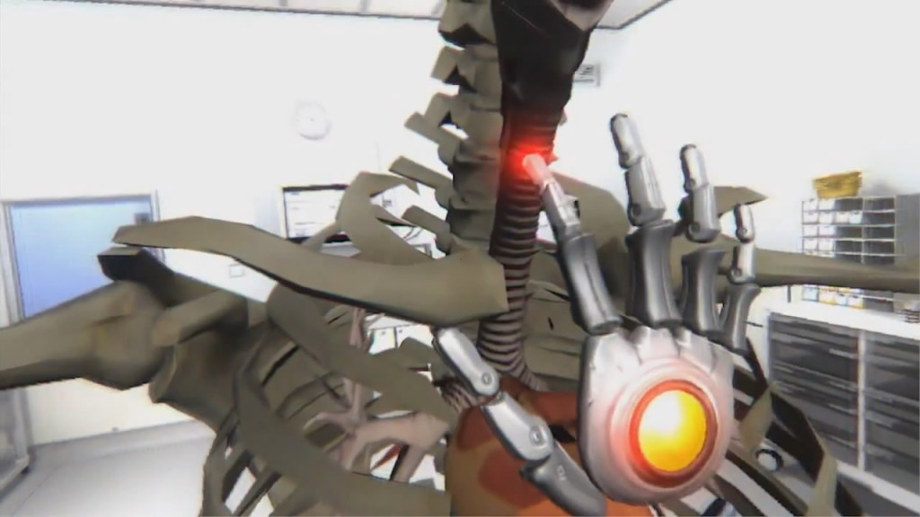

Figure 2-6. World of Comenius – Use Leap Motion Interact with the Virtual human body with just hands [41]

* **Language Teaching**

Scanning cards with tablet computers or phones to discern words, and present relevant pictures or 3D models with pronunciation could help children spell vocabulary and learn pronunciation. The research shows that such learning which integrates touch sense, auditory sense and visual sense more easily stimulates children’s enthusiasm comparing with traditional teaching method and has prominent vocabulary learning effects for non-English native speakers. Using phone to scan vocabulary and present matching pictures and pronunciation also comply with children’s cognitive rules. The Figure 2-7 presents the learning interface of “AR school”English Interface.

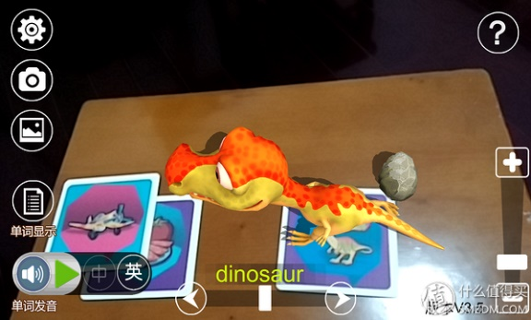

Figure 2-7. Interface of “AR school” English [42]

The VRCLASS Chocoo Interaction developed by Chocoo Company started to develop VR immersive learning system as of 2014 wherein users could stay in various scenes to personally perceive the charms of future mode of learning and communicate with long distance teachers; teachers could fully develop the infinite potentials of virtual space and easily realize the teaching mode that could never be actualized in traditional class. In one class with 50 minutes, teachers usually make traditional teaching in former 30 minutes to lead students to spell vocabulary Figure 2-8(a), such as giraffe, tiger and lion, and ask students to use VR head-mounted equipment to interact with the virtual world in the last 20 minutes. Such practice could consolidate the learning effects. While parents generally approve the efficacy of such teaching method as shown in Figure 2-8(b).



(a) (b)

Figure 2-8. Coqui ABC Immersive Children’s English Learning [43]

* **VR Practical Training**

The introduction of knowledge in specific scenes outside the classroom endows educational experience with unparalleled values. Students do not simply listen to class anymore but follow the interpretation with the head-mounted equipment to obtain real experience in the virtual environment. For instance, the project in the Figure 2-9 is related to the security of construction site. Virtual education expert Inge Knudsen builds up a virtual construction site. This site exists severe security problems. Whereas, students could move around in the virtual environment and take photos in safe places. Such case is nearly impossible in real life. Out of this reason, this is in particular suitable for the virtual world. Personal virtual scene allows students to have experience in any field in work or life in the learning stage. And another example, Hyundai Construction site safety education Virtual Reality[44], shown in Figure 2-10.



Figure 2-9. Virtual Construction Site Program [45]

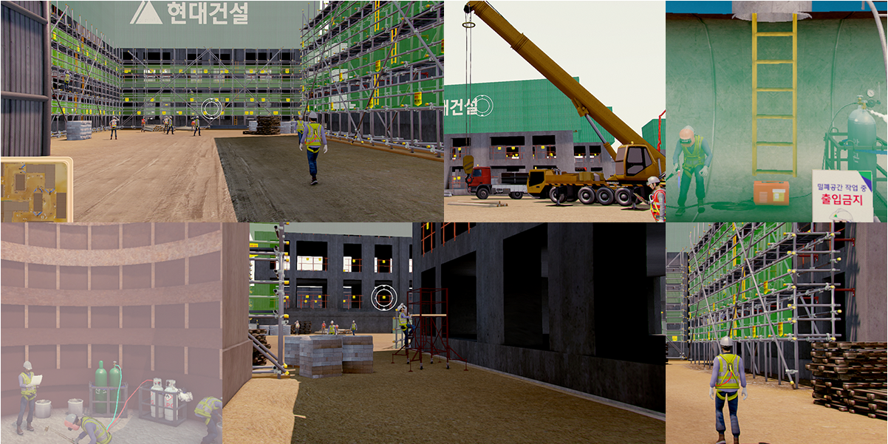

Figure 2-10. Hyundai Engineering Safe Education Program [46]

* **Location Based AR Learning**

Users could seek relevant architectures on the campus according to the real scenes captured by the camera during application use process. Once arriving at the site of target architecture, the camera could automatically discern the architecture information by capturing imaging and present the imaging to users as learning contents. The users could retrieve information at any time and place via phone and the combination of GPS technology and AR technology turns the search process and means of presentation more natural. It not only saves the procedure of manual input. The more important thing is that what you see is what you get. Besides, this software is acknowledged to be a feasible alternative of paper medium. Users have stated the novelty and interest of the means of interaction between phone camera and real physical environment. Similarly, users propose many constructive opinions for the software [47], for instance, the slow network speed of campus wireless network leads to the slow information loading speed, long-term and inaccurate phone GPS operation.

* **Other applications**

The application of ChinAR [48] lowers the threshold of Chinese zither learning, and meanwhile popularizes the most ancient musical instrument in China. Regardless of the benefits of Chinese zither, However, overwhelming learners would give up one month later. Different from other musical instruments, Chinese zither has its own set of musical systems and learners have to learn and adapt to many new concepts and methods in the introduction stage. At this point, its introduction threshold is obviously higher than that of other musical instruments. This thesis gives lots of “hints” to beginners by way of augmented learning technology, greatly lowers the introduction learning threshold, and combines with relevant musical theories at home and abroad to design a full set of interaction methods.



Figure 2-11. Chinese Zither Application [48]

AR technology is capable of turning the originally boring knowledge in teaching to lively images one by one by supplementing virtual information to the real world and improving students’ learning interests and initiative. VR can create a simulation teaching environment that the real world cannot provide. To be specific, special geomorphology, historical figures and events and inaccessible things could be all presented before students through AR technology.

No matter what technologies and what means have been employed, people should pay attention to the integration of learning contents and game elements. Throughout systematic teaching design, the learning contents could be rationally incorporated into the task of educational games under the instruction of learning theory. Situational setting makes for building up an immersive learning situation for learners and helping students have meaningful knowledge construction and exploratory learning.

* 1. 2.2 Interaction Design

2.2.1 The develop of HCI

HCI (Human Computer Interaction) refers to the information exchange between man and computer, including the information provided by computer for people by inputting or displaying equipment, and the manual operation of inputting relevant information to the computer by input equipment [49]. The purpose of man-machine interaction is to discuss how to make the designed computer help people more reliably and more effectively complete tasks. It mainly undergoes three stages [50].

* **Linguistic User Interface**

Low efficiency. Man-machine came into being since the appearance of the first computer ENIAC in the world. Its operating system was completed under directives. At that time, it brought about more sense of mystery of people to computer, and language obstacles impressed people with strong sense of professionalism. Therefore, people needed to proficiently command one computer language for fear of the low-efficiency interaction process.

* **Graphical User Interface**

Strong operability. Graphical user interface is the mainstream category of user interface represented by American Microsoft. It fundamentally changes the routine which takes substantial linguistic forms in the past. One common feature of existing graphical user interfaces is to convey and display information via the window and operate by keyboard and mouse. Since graphical user interface relies on visual recognition and manual control in man-machine interaction process to a large extent, this interface has strong operability.

* **Multi-media User Interface**

Multi-media technology is a kind of transitional technology prior to the advent of natural interaction design technology. Before the invention of multi-media user interface, user interface design has completed the transition from language to graph. However, along with the development of multi-media technology, animation, audio and video media have been gradually introduced into this technology. Especially, the introduction of audio and video media enriches the presentation form of information communication via the computer, creates good conditions for people to well control and convey information and greatly elevates man-machine interaction efficiency. In man-machine interaction, multi-media user interface has an advantage in increasing people’s identification and choices for information. Moreover, a great process has been made in the presentation form and interaction degree with man of computer information communication.

Accompanied by the further advancement of computer technology, information technology and network technology, new interaction technologies and user interface forms such as automatic speech recognition (ASR), glove and other sensors, gesture recognition, hand shank operation, and eye tracking continually spring up.

2.2.2 Interaction Design for VR and AR

As of 2014, the publication of VR entertainment equipment such as Oculus, Gear VR, and HTC Vive makes VR technology serve for ordinary consumers. People have entered a new age of man-machine interaction. Computer creates a simulated real 3D world for users by visual sense, auditory sense, tactile sense and other perception simulated technologies Users are not isolated individuals anymore but turn a part of the virtual environment. Man has established a natural connection with machine [51].

There are diverse VR interaction modes. At present, VR interaction modes primarily include the following seven categories. **Gesture Tracking**: As a kind of mode of interaction, gesture tracking could be divided into optical tracking such as in-depth sensors like Leap Motion and Nimble VR, and data glove which wears sensor on the hand. Microsoft HoloLens is an AR hardware which utilizes gesture in interaction. Once wearing HoloLens glasses, users could control virtual objects and function menu by clicking, dragging and stretching with fingers in the air, such as posing Air tap gesture to open holographic figure or posing Bloom to open the start menu [52]. **Motion Capture**: Whole-body motion capture is not necessary in many scenes. Its problem consists in the shortage of feedback. In consequence, users could hardly perceive the efficiency of their own operation. **Tactile Feedback**. Tactile feedback primarily refers to button and vibration feedback. Next, this section will make a brief introduction to VR hand shank. Nowadays, three leading VR head-mounted manufacturers Oculus, Sony and HTC Valve unanimously adopt the VR hand shank as a standard interaction mode. The so-called VR hand shank is actually a hand shank with two separate handles, tracking function in six free degrees of freedom (including three rotational freedom and three translational freedom), button and vibration functions. **Eye Tracking**: Palmer Laci, founder of Oculus [53] has credited it as the “core of VR” because it could provide optimal 3D effects from current angle based on the inspection of human eye position. Therefore, VR head-mounted imaging appears to be more natural out of its less probability of hysteresis and great entertainment. In the eyes of most VR practitioners, eye tracking technology has become an important technical breakthrough in solving VR helmet dizziness. VR head-mounted FOVE in Japan has already introduced this eye tracking technology. **Voice Interaction**: although gesture operation relieves the two hands, it still has lethal shortcomings – frequent hand raising gesture would cause arm arching. At present, Microsoft Cortana, Google Now, Apple Siri, Amazon Echo are all excellent speech recognition helpers. However, due to their low recognition rate, they could only work as auxiliary operation instrument and corresponding intelligence degree can never reach up to the requirement of AR interaction. By means of speech control, users and the world that they are observing would not interfere each other. More importantly, the voice interaction between users and VR world would turn more natural since users could realize communication in any place and any corner and even do not need to move their heads to seek. **Sensor.** Sensor could help people naturally interact with the multi-dimensional VR information environment. For instance, Virtuix，Cyberith and domestic KAT[54] all commit to the research and development of universal treadmill. Likewise, people who wear whole-body VR suit Teslasuit [55] could personally perceive the changes in VR environment, including the breeze, and even the sense of being struck by a bullet in shooting games. All of these perceptions generate via sensors on the equipment, such as smart sensor ring, temperature sensor, photosensor, pressure sensor, and visual sensor. Such sensors simulate the skin to produce corresponding feelings via pulse current or convey all sorts of perceptions like tactile sense and olfactory sense to the brain. **VR** **Theme Park**: VR theme park [56] The Void exactly adopts this means to construct the virtual world on the physical world so that users could perceive surrounding objects and use real props like hand lamps, sword, gun, and so forth.

Therefore, AR and VR input modes are not unified, and interaction mode is also rather diversified. In practical application, the most practical means is to customize the most appropriate mode of interaction according to the features of application.

2.2.3 User Interface Design for VR and AR

GUI design needs to consider how to better present the information and create convenience for browsing and interaction. At present, the generally used user interface is flat interface design and people could hardly break up the hard in the short run. As a consequence, it could be also used in AR and VR interface. The advantage of flat design is its ability to (1) better present contents and data and avoid the interference caused by multiple visual elements to information discrimination; (2) cater for transparency effects convenient for users’ observation of outdoor environment. Taking Google tilt brush for example, it is a color picker provided by the software similar to commonplace desktop software (in flat style). Instead, it does not a box of “paint” for slow color modulation.



Figure 2-12. Flat Design User interface in Google tilt brush [57]

1. . VR Art Exhibition

Virtual Reality (VR) is widely used in various fields, and it is expanding game movie towards health care, business software, education and web service. Especially various researches are being conducted in the field of exhibition, and methods for implementing Attachable-removable HMD (Head Mounted Display) VR contents using a smart phone are being presented. The VR technology in the field of exhibition solves both the time, space constraints and the unilateral information transfer to the exhibitions displayed in the offline exhibition. The advantage has that this can overcome the quantity, time and the geographical constraints that should be met by direct visits. The virtual art exhibition application can allow users to appreciate art works at any time without leaving home, which breaks the time and space constraints.

* 1. 3.1 Game Design

According to the role of this game, we choose the virtual presentation mode of Mobile + VR. Among the Mobile + VR devices, the Samsung Gear VR indeed has better leak-proofness, but you must have one of the latest Samsung phones such as the Galaxy S6, Galaxy S6 edge, Galaxy Note4, Galaxy Note5, and Galaxy S6 edge+. Google Cardboard has the same experience, the cost is relatively low, and both Android and Apple iOS system are supported, so that it can be used on most mobile phones, it is a good choice as a VR entry-level experience. In the Google Cardboard introduction page, there is such a sentence "Experience virtual reality in a simple, fun, and affordable way" summed up Google Cardboard has the following advantages compared to other mobile VR products: 1, cheap, 2, easy to carry, 3, while supporting both Android and IOS phones with appropriate screen size. Therefore, this game we have selected Google Cardboard as a game device. Users can also assemble Google Cardboard according to the introduction. The assembly diagram is as shown below.



Figure 3-1. Google Cardboard [58]

This application is a multimedia mobile visual VR application using Google Cardboard. Users can experience the virtual art exhibition from the first-person view. Because the interaction ways that supported by Google Cardboard and mobile phones are very simple and limited, we have used users’ gaze direction to control the direction the user want to move toward. After the application starts, the character moves in the direction of the user's gazing direction and stops when it enters a certain distance in front of the painting or the obstacle. The user can watch the painting and continue to move by changing the gazing direction.

3.1.1 Composition of Contents

Different from the actual exhibition halls, the most important thing is to ensure the distortion of the Virtual Reality visual contents are minimized, so that can improve the users’ subjective initiative and immersive sense. Flexible use of virtual reality display technology and analysis of visual content from an aesthetic perspective. It is also important to decorate the display environment as real as possible. The digital exhibition works was obtained by the basic offline exhibitions. There are totally of seven art works in this application. Figure 3-2 are shown 3 of them.

  

(a) [59] (b) [60] (c) [61]

Figure 3-2. Works of Art

3.1.2 Immersion for VR Exhibition

In this section, we explain various analytical methods to increase the immersive and experiential factors by moving multimedia visual design contents that presented in offline exhibition to virtual reality. The HMD devices basically has a characteristic that provides experience and immersion. However, when the offline content is changed to digital content, it is assumed that the problem raised in the previous is to be solved in this paper. Focusing on enhancing immersion and experiential factors through solving these problems. In particular, Galvis defines the disturbing elements as follows [62]. "It was pointed out that if the display image size was small, and the stereoscopic effect was low, the motion was not reflected properly, cannot obtain a complete immersion. The lower the resolution of the screen support lower the immersion. " On the experiential side, the obstacle to HMD immersion is "I can move freely, but the result of the movement cannot be visually reproduced similar to reality". Based on the problems raised above. As shown in Table 3-1, we suggest solutions for enhancing experiential factors and immersion.

Table 3- 1: Influencing Factors of Immersion in Virtual Reality Display

|  |  |
| --- | --- |
| Division | Experience and immersion factors |
| Display Performance | Contrast ratio, Color recall, Color depth, Color temperature, Gamma curve, Luminance |
| Image Resolution | Difference in image resolution. |
| Image Size | Difference in image size when using HMD device. |
| Exhibition layout | Shading and shadow effects |

The elements that can enhance the immersion feeling to show the intention of the artist in the exhibition works can be judged to be the degree of experience that stimulates the elevated enjoyment, and curiosity. In exhibition works, such factors as color and layout can be considered according to the artist's intention, but it is difficult to apply it to the overall works. For this purpose, the proposed method in Table 3-1, that through create an exhibition environment, active experience of multimedia visual contents can be enhanced as an experiential factor.

3.1.3 Interaction Design and Operating Mode

In terms of user interaction, in order to use Google Cardboard as a tool to implement multimedia exhibits, the interaction mode is particularly important, especially if you want to approach the actual exhibition, the interaction mode must follow the natural interaction as much as possible, through analysis of the hardware conditions of Google Cardboard, Using the way of the user's FPV to interact, the user in the virtual world automatically advances toward the direction, and stops when entering a certain range near the art works or obstacles. At this time, the user may stop to view the painting or walk away by change the direction of view to change the direction of movement.

* 1. 3.2 Implementation

This application uses Unity 3D 5.1 as a development tool. Unity has built-in support for virtual reality from 5.1. Download CardboardSdkForUnity. packadge and import it into Unity project. In the hierarchy panel, use Cardboard Main Prefab instead of standard camera, check the Virtual Reality Supported option in project setting, and then the game can be switched to VR mode preview. The following is the main code for the user to move and determine the obstacle part:

Object\_walk\_speed = 2;

Transfrom(forward, Object\_walk\_speed);

Distance = Calculate\_Distance(Target.Position, Object.Position);

if Distance < 3

then Object\_walk\_speed = 0;

else

then Object\_walk\_speed = 1;

The application development environment is Windows 10 64bit, Unity3D 5.1, and the development language is C#. The hardware devices are Google Cardboard and Samsung S4 smart phones. The following Figure 3-2 shows the program execution scenes and various visual design contents in a virtual environment, Figure 3-2(a) shows the Art Exhibition room. Figure 3-2(b) shows the Art works in front of user. With the respect to a better [artistic](javascript:;) [design](javascript:;) of the exhibition room, the effect and experience are not inferior to those in the reality world exhibition hall.



(a) The Art Exhibition Room



(b) The Art work shows in front of user

Figure 3-3. Game Scenes

* 1. 3.3 Conclusion

The virtual display application is the trend of the development of artistic activities. It breaks through the limitations of time and space. With virtual reality technology, designers can build virtual exhibition space according to their own creativity. Users can observe the work from any angle. The organizer can update the display content at any time. Nowadays, smart phones have become popular and become our daily necessities. You can easily use a variety of applications through your smart phone. With Google Cardboard and smart phones, allows people who are passionate about art appreciation to visit art exhibitions anytime and anywhere. This research analyzes the factors that affect user experience and immersion, explores the design of virtual reality art in the display environment of new media art, and can better reflect the Combine of science and technology and art. Serving society in a wider range and based on existing conditions proposed ways to improve user experience and immersion.

1. . AR 3D Coloring Game

At present, AR technology has begun trial application in military, medical, commercial, education, and maritime training, some success has been achieved. The combination of education and AR technology brings about innovative development in education [23]. In the previous chapter we mentioned the applications of AR e-books. Described the features of AR technology and the applications of AR technology in education and developed "Color the Earth" - a fun application which filling the earth parts with different colors, the other one is "Color Xi Xi" – color the cartoon characters’ clothes with different colors. The "Color the Earth" aims to help young children understand the distribution and location and outlines of oceans and continents by coloring them on the earth model, the users also can understand the rules and knowledge of celestial movement through a 3D dynamic representation of the Earth model and the solar system animation. the "Color Xi Xi" enhances young children's perception of color through an easy coloring process.

This chapter makes a more detailed analysis of the characteristics of AR applications, product design and implementation technologies. These two AR games enable a planar picture stand vividly revealed on the paper through a simple and portable mobile terminal scan. Multiple forms of interaction also stimulate the interest of learners and enable them to interact with 3D “buddies” and understand the world in the process. Break through the limitations of paper books, promote the acquisition and absorption of knowledge, improve the interactive effect of teaching, and fit in with the concept of entertaining, improving the students' ability to operate, identify and identify colors. AR as an emerging learning medium, e-books will have a disruptive impact on the classroom environment, the teaching model, and even the education field.

* 1. 4.1 Game Design

AR technology is a combination of virtual image and reality. Interaction should be the main focus of AR. However, due to the fact that smart glasses are not formally launched, AR technology still stays on the screen of mobile devices, resulting in many AR technologies introductions are like gimmicks, AR applications are still mainly based on acceptance visual experience. Coloring AR products are a few successful products in the current AR market. They have the following characteristics: high interactivity and entertainment; can be used independently or as part of the system, less investment compared to traditional games; collaboration between different domains is required, and UV map matching requires a higher level of computation. The color rendering has two ways: First, real-time rendering model texture content; Second, only rendering the model texture once receive instructions.

4.1.1 Color the Earth AR

The gameplay is focus the camera of the mobile phone or a tablet on the picture of the coloring paper. The recognition picture in the screen is red and turn to green when the picture is completely contained in the scanning frame on the screen, this means the recognition is successful. The success mark shows on the screen, and the 3D effect of the earth model appears on the recognition picture paper. Users can interact with the model by clicking on the earth model on the screen, click once make the earth model rotate, click twice the solar system animation show on the screen. The game flow chart is shown in the Figure 4-1 below.

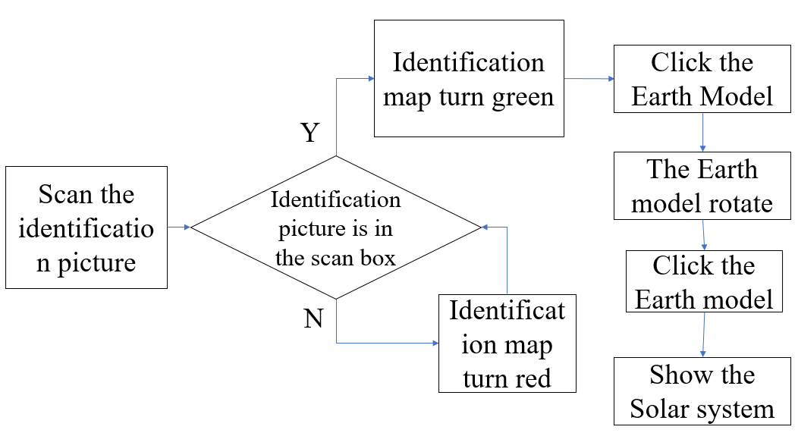

Figure 4-1. The playing flow chart of Color the Earth AR

4.1.2 Color Xi Xi AR

This application can be run on mobile devices, easy to operate, and portability, with just a few pieces of paper or cards to experience anytime and anywhere. The design motivation of this app is to help children know the colors and express their favorite collocations. children can also observe their designs and collocations from different angles. Using the camera of the mobile phone or a tablet to scan and identify picture1, the original color character model will be displayed on the top of the identification picture for reference, after identifying identify picture1 then color identify picture2 which has only outlines of identify picture1 and with no colors, when get the color done, scan the identify picture2 to see the 3D effect that the user has filled in color, shown in Figure 4-2 below.

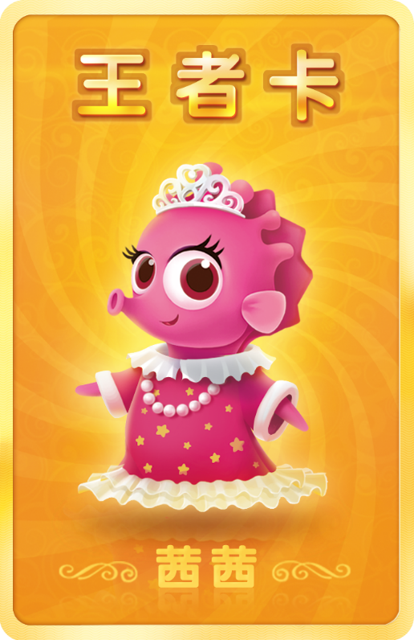 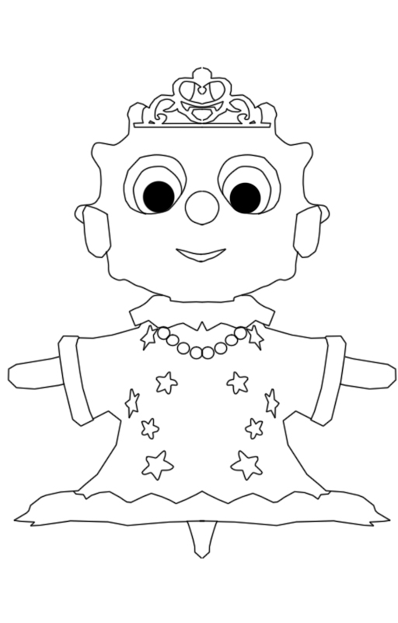

(a) Picture1 for AR (b) Picture2 for coloring AR

Figure 4-2. The recognition pictures

* 1. 4.2 Implementation

Recognition picture and models are the main components of the coloring AR applications, and to connect them requires UV splitting and matching. UV is the abbreviation of u v texture map coordinates. It is a two-dimensional texture coordinate point that resides on the vertices of a polygon mesh, these points are defined as a two-dimensional texture coordinate system called a UV texture space. This space defines the axes with two letters - U and V. It is used to determine how to place a texture image on a 3D model’s surface. UV is the mapping of the texture to the model's coordinates. In addition, the prepared AR identification picture needs to be uploaded to the Vuforia website for certification before it is downloaded and used as an identification picture. The position of the identification picture and the model is integrated in the Unity 3d game editor, and the color is obtained through the screen capture, and the Shader parameters are passed to determine the color on the corresponding position of the model. Finally, the painted 3D model is displayed on the identification picture paper. The production flowchart is as follows.

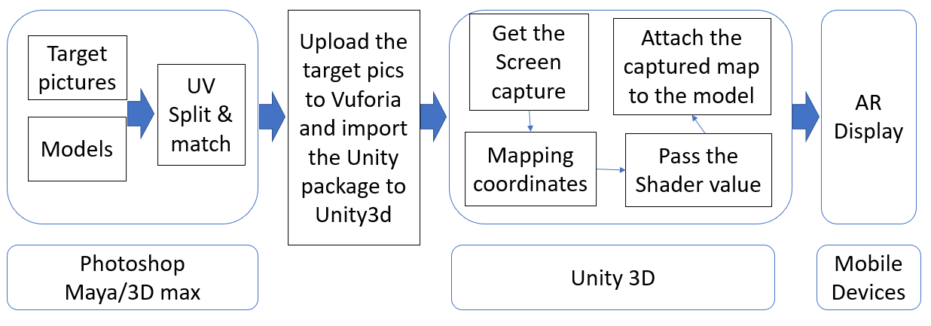

Figure 4-3. The flowchart of coloring AR

Color the earth AR and Color XiXi are all coloring AR applications, and both are implemented according to the flowchart shown in Figure 4-3 above. So that we only choose＂Color the Earth AR＂as an example to describe the production processes and steps.

4.2.1 Color the Earth AR

First, software used in implement of the ＂Color the earth AR＂ application are: PhotoShopCS5 - to create plane recognition pictures, Maya 2015 - to create Earth and other models, and Unity 3d to integrate all resources and add control code.

**• Identification Pictures**

Two pictures are need, first which is shown as Figure 4-4(a) is used as an identify card which the earth part has no lines or colors, if you add any content to this part even simple black lines, they will become part of the identification information that when it is covered with colors, it may reduce the recognition affects and the recognition rate, the second figure which as shown in Figure 4-4(b) is used for reference for modeling and for UV positioning and matching, which is also the identification picture that the users eventually obtains.

 

(a) The picture1 for register (b) The picture 2 for identification

Figure 4-4. The identification pictures

* **Vuforia Configuration**

The image created in the previous step needs to be uploaded to the Vuforia website before it can be used as an AR identification picture. The Vuforia website provides the mobile AR development SDK. After the user uploads an image to the website, the website will identify the image based on the color and outline of the image. The logo identifies the registration, as shown in the Figure 4-5 below. The identification picture in this application is given five stars.



Figure 4-5. The recognition level of the picture

* **Modeling**

When modeling using Maya, the Model should match with the identification picture as much as possible. Use some basic geometry such as spheres and cylinders or the deformed geometry of the basic model to make the tellurion model, divide the functionally different models into separate parts.

In addition, modeling should consider the users’ viewing angle when they watching the model. In general, the [top](file:///E:\youdao\Dict\7.5.2.0\resultui\dict\?keyword=top)[view](file:///E:\youdao\Dict\7.5.2.0\resultui\dict\?keyword=view) and [front](file:///E:\youdao\Dict\7.5.2.0\resultui\dict\?keyword=front)[view](file:///E:\youdao\Dict\7.5.2.0\resultui\dict\?keyword=view) are easy to attract people's attention, as shown in the Figure 4-6(a) is the top view and (b) is the front view of the model, in these part should minimize the texture stretching. For the part that cannot be seen by the user. As for the other parts of the model which cannot be seen clearly and frequently the details can be reduced, shown in Figure 4-7, the shaded parts are almost invisible. However, in order to achieve aesthetic effect these parts cannot be deleted.

 

(a) [Top](file:///E:\youdao\Dict\7.5.2.0\resultui\dict\?keyword=top)[view](file:///E:\youdao\Dict\7.5.2.0\resultui\dict\?keyword=view) (b) [Front](file:///E:\youdao\Dict\7.5.2.0\resultui\dict\?keyword=front)[view](file:///E:\youdao\Dict\7.5.2.0\resultui\dict\?keyword=view)

Figure 4-6. The viewing angles at the model

 

(a) The inside of the tellurion frame (b) The bottom of the model

Figure 4-7. The invisible parts of the model

During the modeling with Maya, attentions should be paid to the three important operations: freezing the transformation, deleting the history, and returning the coordinate axis to the center of the object.

**• UV Matching**

This step is a bit cumbersome and it is implement in Maya. As the concept of UV introduced in the previous section. UV is actually a kind of 2D plane coordinates. The correspondence between the points on the model and the position on the plane coordinates. The following Figure 4-8 shows the UV coordinates.



Figure 4-8. The UV coordinates and screen coordinates

UV split and matching directly affects the effects of the model matching and picture stretching. In the coloring AR applications, although image stretching cannot be avoided completely, we can reduce the stretching situation by putting the stretched parts to the unobtrusive places as Figure 4-7 shows. Unfold UV and divided into different parts according to the model and match the UV with the colorless tellurion part on the identification picture. Those parts that are not easy to see by the user can be reduced and overlapped with other similar ones.

The Figure 4-9 shows the UV matching of the tellurion model, (a) is the earth part matching. (b) and (c) shows the tellurion frame matching.



(a) The earth part matching



(b) The tellurion frame details matching



(c) The tellurion frame matching

Figure 4-9. UV matching of the tellurion model

* **Integration in Unity 3D**

Export the model from Maya, download and install Unity (version 5.3.4 or later), build the Unity Android development environment, that is configure the Android platform publishing environment parameters (JDK and SDK), create a new unity project, import the model and picture which is download from the Vuforia website, other resources that will be used into the Unity project, create Canvas to place UI elements, and set their location, as shown in Figure 4-10 below.



Figure 4-10. Unity scene view

* **Texture Coordinate Calculation**

When the camera is turned on, we need to determine whether the screen coordinates of the recognition picture’s four vertices are within the scanning frame which is semi-transparent and in the center of the screen. To know the coordinate range of the recognition picture on the screen, we need to further understand the screen coordinates, as shown in Figure 4-11. Similar to the UV coordinates, the origin of coordinates both from the lower left corner, the screen resolution set in this project is 800 x 600. Therefore, the coordinates of the four vertices of the screen can be obtained.



Figure 4-11. [Screen](file:///E:\youdao\Dict\7.5.2.0\resultui\dict\?keyword=screen)[coordinates](file:///E:\youdao\Dict\7.5.2.0\resultui\dict\?keyword=coordinates)

The following Figure 4-12 shows the relationship between the identification picture, the scan box and the screen. The gray part is the scan box, the blue part is the identification picture, and the screen coordinates of the four vertices of the scan box are acquired (U\_Point). The world coordinates of the identification picture four vertices (targetAnglePoint ) are converted into screen coordinate points (P\_Point) by comparison and judgment P\_Point and U\_Point, that is, whether P\_Point1.x > U\_Point1.x, P\_Point1.y < U\_Point1.y, P\_Point2.x > U\_Point2.x, P\_Point2.y > U\_Point2.y, P\_Point3.x < U\_Point3. x, P\_Point3.y < U\_Point3.y, P\_Point4.x < U\_Point4.x, P\_Point4.y > U\_Point4.y combination of the conditions is true, determines whether the identification picture is completely in the scan box. If true the identification picture will turn green, otherwise it will turn red.



Figure 4-12. The relationship between the identification picture

As the Figure 4-13 shows, it is known that the gray rectangle’s center point coincides with the position of the white rectangle. The gray part is the size of the screen, and the white part is the size of the identification box. In this application, it is set as a = 800, b = 600, c = 400, d = 300, we need to get the coordinates of the four vertices of the white rectangle, that is U\_Point1 (g, r) U\_Point2 (g, h), U\_Point3 (e, r), U\_Point4 (e, h), through the positional relationship between them we can get the values, g = (a - c) / 2 = (800-400) / 2 = 200; h = (b - d) / 2 = (600-300) / 2 = 150; e = (a + c) / 2 = 600; r= (b + d) / 2 = 450; Now we get the screen coordinates of the scan box (white rectangle): U\_Point1 (200,450), U\_Point2 (200,150), U\_Point3 (600,450), U\_Point4 (600,150).



Figure 4-13. The texture coordinate calculation

However, in order to adapt to different size of mobile devices, record the four points of screen coordinates are as follows, where 400,300 is the size of the scan box. “X\_Sc” is the scaling value of the screen (because it is based on the width scaling so only use one single variable).

U\_Point1 = new Vector2

(Screen.width - 400 \* X\_Sc, Screen.height + 300 \* X\_Sc) \* 0.5f;

U\_Point2 = new Vector2

(Screen.width - 400 \* X\_Sc, Screen.height - 300 \* X\_Sc) \* 0.5f;

U\_Point3 = new Vector2

(Screen.width + 400 \* X\_Sc, Screen.height + 300 \* X\_Sc) \* 0.5f;

U\_Point4 = new Vector2

(Screen.width + 400 \* X\_Sc, Screen.height - 300 \* X\_Sc) \* 0.5f;

To determine whether the screen coordinates of the picture are within the scan frame, the screen coordinate range of the recognition picture needs to be obtained. To get this requires obtaining the world coordinates of the image vertices first and then converting them to screen coordinates.



Figure 4-14. The world coordinates of the image vertices

targetAnglePoint1 =

transform.position + new Vector3(-halfSize.x, 0, halfSize.y);

targetAnglePoint2 =

transform.position + new Vector3(-halfSize.x, 0, -halfSize.y);

targetAnglePoint3 =

transform.position + new Vector3(halfSize.x, 0, halfSize.y);

targetAnglePoint4 =

transform.position + new Vector3(halfSize.x, 0, -halfSize.y);

The screen coordinates P-Point1, P-Point2, P-Point3, P-Point4 of the four vertices of the patch are obtained by the following code.

P\_Point1 = WorldToScreenPoint (targetAnglePoint1);

P\_Point2 = WorldToScreenPoint (targetAnglePoint2);

P\_Point3 = WorldToScreenPoint (targetAnglePoint3);

P\_Point4 = WorldToScreenPoint (targetAnglePoint4);

In this step, the model is displayed on the recognition map, and the screenshot image is attached to the model as a map. The position information of each vertex calculated by the coordinates in the previous step is passed to the Shader, and the UV configuration and stretching is performed in the Shader.

* **Add UI and Interaction**

Further improvements in this step include buttons, prompts and the scan frame, etc. It should be noted that, first of all, set the anchor point in the center position, pay attention to the influence of screen self-adaptation on the screen coordinates. According to the introduction in the previous section and the gameplay. The programming logic diagram shown in the Figure 4-15.

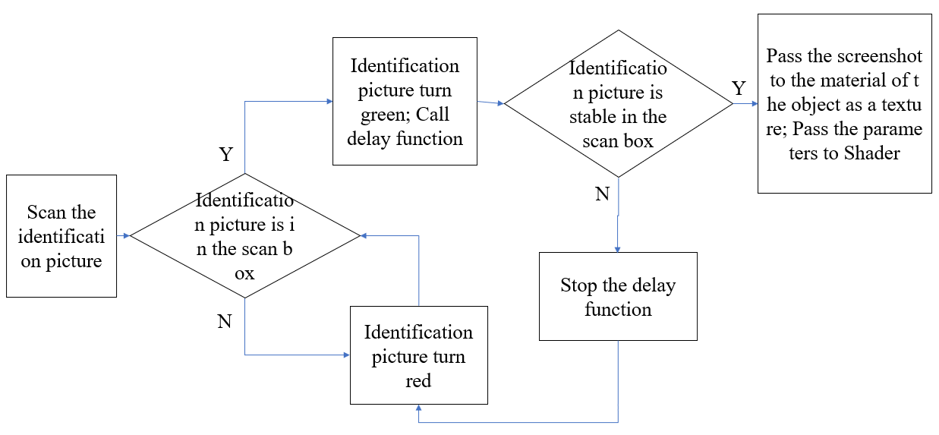

Figure 4-15. The programming logic diagram

Use the following code to determine the conditions and change the color of the identification picture.

if (Identification map is in the scan box)

{

gameObject.GetComponent<Renderer> ().material = Sp\_Green;

}

else {

gameObject.GetComponent<Renderer> ().material = Sp\_Red;

}

* **Get the Screenshot Image**

The standard format of getting the screenshot: Texture2D (int width, int height, TextureFormat format, bool mipmap); "int width, int height," texture’s width and height "TextureFormat format" texture’s pattern such as RGB24 RGBA32, etc. "bool mipmap" - mipmap is a hierarchical texture that gives different levels of texture when the screen size is different.

Get the ScreenWidth : Screen.width;

Get the ScreenHeight: Screen.height;

TextureShot = new Texture2D (ScreenWidth,ScreenHeight, TextureFormat.RGB24,false);

Get the pixel information of the screen the first "0,0" gets the starting point of the screen pixels, "ScreenWidth, ScreenHeight" gets the range of the screen pixels, the second "0,0" fills the coordinates when filling texture2D, and then give the obtained texture information to the tellurion model.

The following is the Color the Earth operation diagram. In Figure 4-16(a), the identification picture does not completely enter the identification frame and is displayed in red. After the identification map in Figure 4-16(b) is fully entered into the identification frame, it is displayed in green, indicating that the identification of success shows in Figure 4-16(c), Figure 4-16(d) for coloring a globe model, Figure 4-16(e) shows the Solar system movement animation. All operations are completed by just clicking.

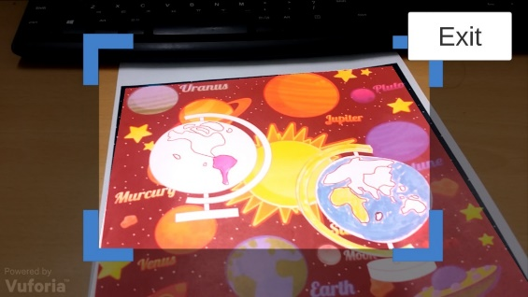 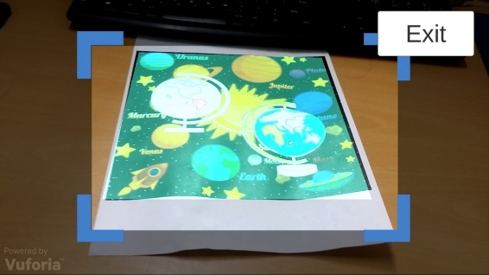

(a) The identification picture does not completely enter the identification frame (b) The identification picture fully in the identification frame

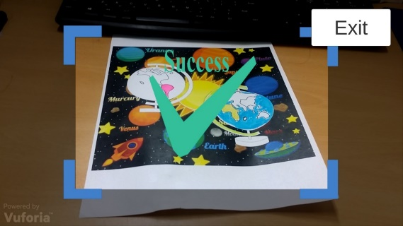 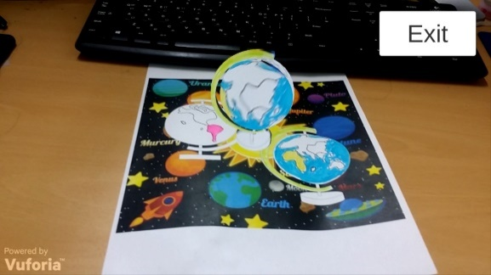

(c) Recognition successfully (d) Show the colored earth model

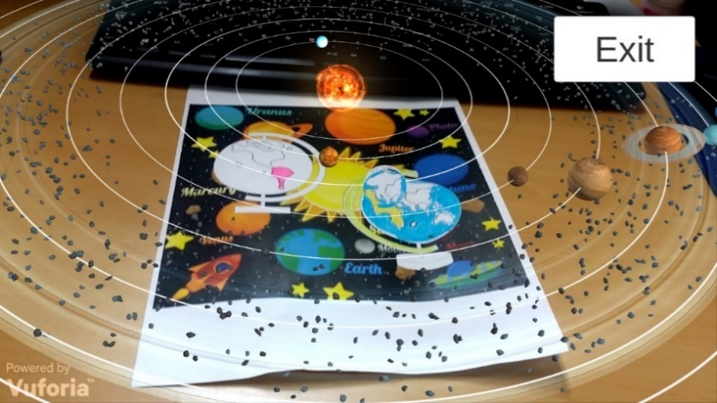

(e) Solar system movement animation

Figure 4-16. Game scenes

4.2.2 Color Xi Xi AR

Based on the knowledge and methods of coloring AR application development, another fun cartoon character painting and dressing application suitable for young children was developed.

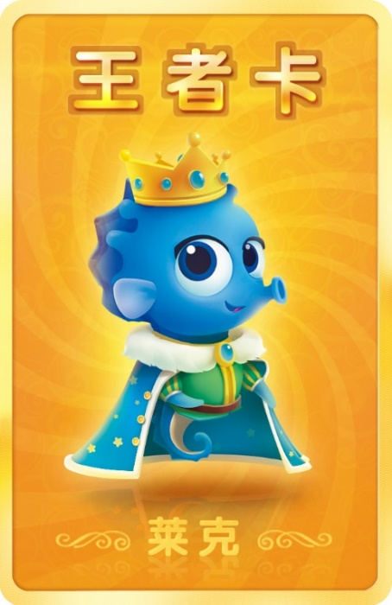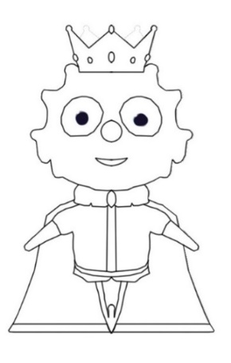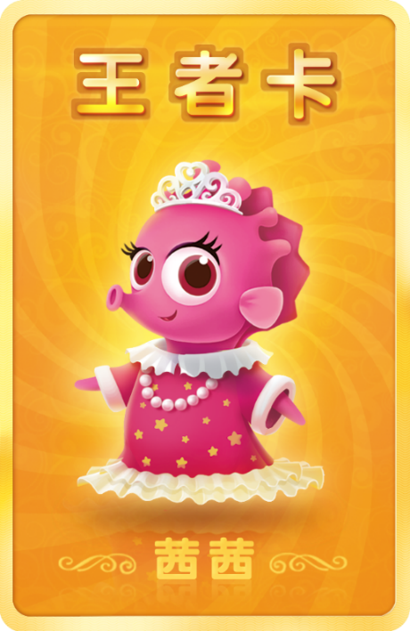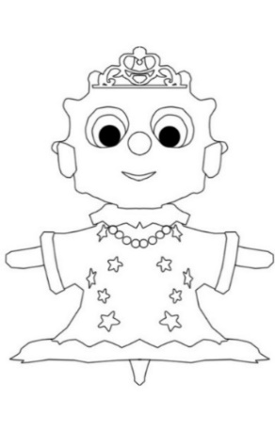

Figure 4-17. Two characters’ original and sketches for recognition

Two characters correspond to two recognition pictures, shown in Figure 4-17, and the 3D model of each character has an animation effect. When the user covers the original picture with a piece of paper covered with colors, shown in Figure 4-18, the character model will also change its clothes color. The Figure 4-18 show the scene of one of the characters when the application running.

 

(a) The sketch of the model (b) The colored XiXi Model

Figure 4-18. The XiXi Model

The steps of using this application are as follows: (1) Color the identification picture with colors, shown in Figure 4-19(a); (2) running the application with a mobile device, scan the picture using camera, and then the 3D dynamics model will be appeared at the top of the picture, shown in Figure 4-19(b); (3) Children can replace the corresponding identification picture parts of the model’s clothes with other colors, shown in Figure 4-19(c); (4) Run and see the changed clothes color on the model, shown in Figure 4-19(d).



(a) (b) (c) (d)

Figure 4-19. The running screens of Color Xi Xi

* 1. 4.3 Conclusion

According to the application characteristics of AR in the field of education: that is, the concept of inquiry-based education, attract children to participate in teaching from the form of expression, and enhance the interest in things, so as to explore and research more in-depth contents in an interactive manner. The multi-media approach is more expressive, and after being integrated into AR technology, the content of the teaching is expressed in pictures, videos, animations, etc., making it easier to understand. The new interactive experience, augmented with the unique interactive experience of real life, allows children to use their eyes, ears, hands, and brains to truly realize diversified education.

The application of AR technology in education provides new ideas for teaching and learning. The application of coloring can be said to be its representative application. The AR 3D e-book breaks through the limitations of paper books and provides learners with realistic and intuitive simulations. Learning materials promote the acquisition and absorption of knowledge. Through the simple and convenient scanning of the mobile terminal, the planarized object can be “moved on paper”. The interactive form stimulates the learner's interest in learning and enables them to learn knowledge and understand the world in the interaction with the concept of three-dimensionality. In Color the Earth application, young children improve their hands-on ability and understanding of colors through hand-painted colors, and more importantly, through the combination of educational content, young children have a preliminary understanding of the movement of the earth and celestial bodies and stimulate exploration interest. The Color Xi Xi application also has a more sensitive understanding of colors, but also allows children to enjoy the fun of matching costume colors. Of course, AR 3D e-books are in the development stage. Whether it is the fidelity or interactive effect of 3D models, there are deficiencies, which need to be further improved in the later research and production. With the advancement of smart classrooms and digital learning, AR 3D e-books as new learning media will have a disruptive impact on the classroom environment, teaching model, and even education.

1. . MR Chemistry Lab

The conventional education system modes are primarily passive or receptive learning style, many teachers think that students learned the experimental principle and method is important and enough, so they no need to do many experiments, according to our research, present teaching methods have limits shows as below: First: Lack of motivation and of activity, students are shown the experiments results instead of probing the results. Second: Temporal and spatial constraints; students cannot do the experiments anytime and anywhere for the limits of objective conditions and cannot repeat the experiment steps. Third: Wasted reagents and danger, some of the reagents are dangerous, therefore many practices are requisite before using the real ones. In this way can save the reagents and lessen the danger. Fourth: The pollutants have not been processed. To break the limits as we build up this application, use this can let the users practice the experiments wherever and whenever they need in a more active and probing learning way, and can also can save the reagents and lessen the danger probability. Meanwhile compare to the general 2D chemistry applications it guarantees the immersion almost alike the real world, in addition we also design a feature that users can see the microcosmic things like molecular structure using mark AR. All the solutions are confirmed Improved learning efficiency.

MR Chemistry Lab is an educational experience that can virtually simulate lab procedures and important lab safety measures. The user is immediately immersed inside a VR laboratory and can begin walking around using the Oculus HMD to interact with the environment. There are lab procedures and safety guides spread across the tables, and a great deal of lab equipment that can be picked up, placed, thrown, or actually used in real lab procedures. Through virtual experiment, students can perform simulation experiments in an environment closest to real, familiarize with the experimental process, observe and record experimental phenomena, save reagents, reduce danger, and achieve the goal of learning at anytime and anywhere.

* 1. 5.1 Game Design

The chemical knowledge involved in this application is a simple chemical experiment - Magnesium ribbon combustion. Observe that a substance can generate other substances through chemical experiments. Through this experiment students can understand what a chemical experiment is.

The phenomenon of this experimental is: Intense burning; Emitting dazzling light; Generate smoke; and the Magnesium ribbon turn to white solids. The effect of the dazzling white light emitted when the magnesium ribbon burned was achieved by a particle system. The burned magnesium ribbon was placed in a beaker containing acetic acid. The magnesium ribbon was gradually dissolved without bubbles; the unburnt magnesium ribbon was put in the beaker containing same acetic acid. Observe the beakers, magnesium strips were gradually dissolve, and bubbles were generated in the beaker.

The experimental principles and reaction equations involved are as follows: The combustion reaction of the magnesium ribbon changes the arrangement of the atoms.

2Mg + O2——ignite——2MgO  (1)

Mg + 2CH3COOH ——(CH3COO)2Mg + H2（ ↑ ） (2)

2CH3COOH + MgO=(CH3COO)2Mg + H2O (3)

Eq (1) Magnesium is ignited under oxygen generate magnesium oxide. Eq (2) Magnesium Rod produces Magnesium acetate and Hydrogen in acetic acid solution. Eq (3) Magnesium oxide produces magnesium acetate and H2O in acetic acid solution.

According to the education content described above, two implementation methods are adopted: Mobile + PC + Leap Motion and PC + Oculus HMD. When running on Android phones, you need to use Leap Motion's gesture recognition to interact and implement the experiment process. However, since Leap Motion doesn't yet support running directly on the phone, we use Unity 3D Engine + Remote, which is the Unity Remote function that runs on Unity in the PC and is displayed on the phone screen. In order to achieve the combination of virtual reality and Leap Motion. it is divided into AR part and VR part, VR part is virtual chemistry experiment, and there are three experiments designed. Due to the model and some experimental effects, we only test the first experiment, which is the “burning of magnesium bar” experiment. In the AR section, the atomic card is scanned to show the model diagram inside the atom. Under the condition of PC and Oculus, the experiment was performed through the Oculus handle Controllers, and the virtual reality screen was displayed through the HMD. The detailed design are as follows.

5.1.1 Leap Motion

The program contains two parts: VR part and AR part. The design flowchart is shown as in Figure 5-1. The Experiments part is run in VR mode and the Expansive Learning part is run in AR mode. So that the project has been divided in three scenes, Main scene, VR scene and AR scene. The experiments are carried out in a virtual reality scene. In Experiment 1, there is an experiment table with experimental information cards, alcohol lamps, beakers, and magnesium ribbons, etc.

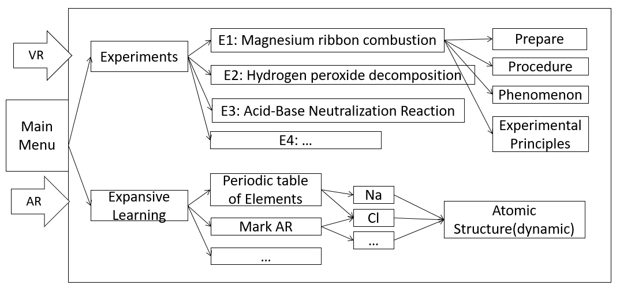

Figure 5-1. The flowchart of MR Chemistry Lab

Users interact with the experimental apparatus using Leap Motion. Since Leap Motion is based on the gesture recognition. It is a more nature interaction way than others.

5.1.2 Oculus HMD

In the case of using the Oculus HMD and Controllers, it is divided into the Main scene and the ChemVR scene. In the Main scene, the main function is to select experiments and recognize the atomic structure model of the necessary elements in the periodic table, as shown in Figure 5-2. the middle of the scene is the periodic table of elements, the user can use the handle to control the cursor to select the experiment in the left menu bar, the corresponding experimental information and description will appear on the right, at the same time, the elements involved in the experiment will be highlighted, the user through the operator the handle on the handle can be pointed at the element to handle the element's atomic structure model with the handle pulled in front of eyes, as shown in Figure 5-2.

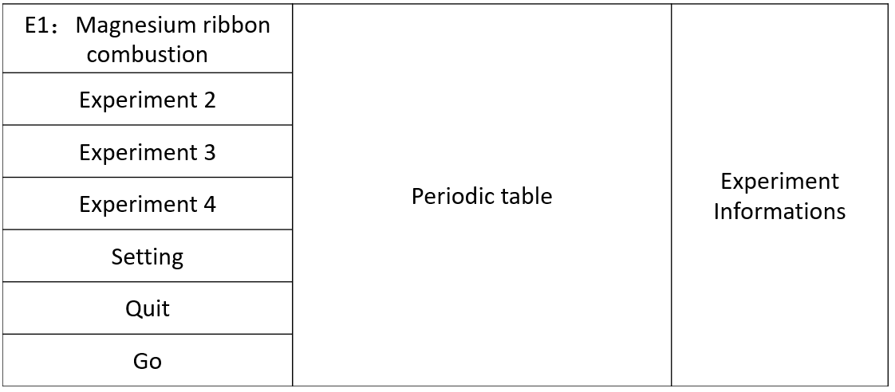

Figure 5-2. Main scene

The virtual laboratory can simulate scenes that cannot be provided by real chemical experiments and strengthen students' understanding and memory through multiple sensory stimuli. For example, some microscopic experimental phenomena can be presented in a macroscopic way, such as the stereoscopic image of an atomic structure. After selecting the corresponding experiment in the periodic table, the atomic structure model of the element involved in the experiments is highlighted to the users. Using Oculus Touch Controllers The users can move, rotate, and scale the structure models to deepen understanding the atomic structure.



Figure 5-3. Drag the element's atomic structure model to the front

After observing the experiment information and element's atomic structure models, select the experiment to be performed. Click the Go button to jump to the VR lab scene “ChemVR”. The ChemVR scene has the same UI layout, the left is the experimental information menu, click, the corresponding information appears in the middle panel. The user is in front of the experiment console, as shown in Figure 5-4. The user can refer to the displayed experimental procedure to start the experiment and observe the phenomenon.

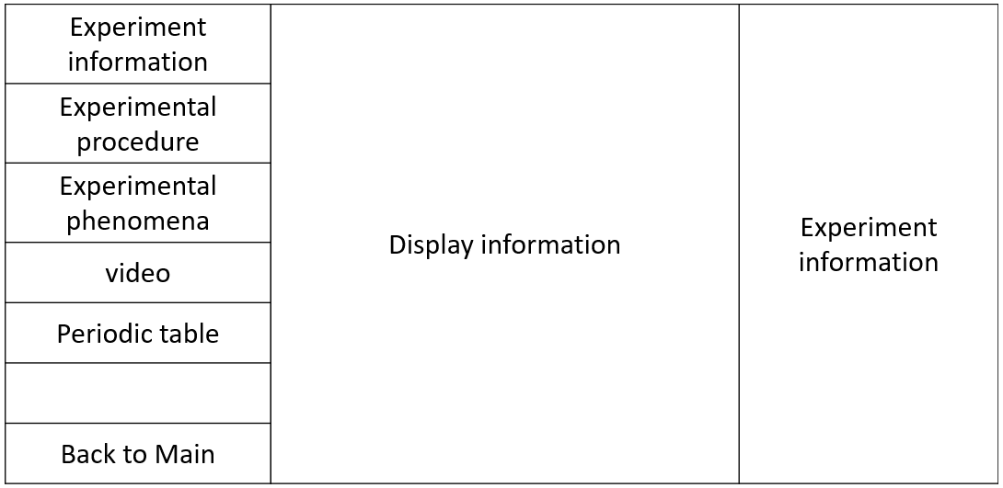

Figure 5-4. ChemVR scene

* 1. 5.2 Experiment procedure

On the experiment desk shown as in Figure 5-5, there are silvery white magnesium ribbons; the asbestosgauze on the lab table is to prevent the product from splashing down after burning, and on the asbestosgauze there are two magnesium ribbons. Before the experiment, it is necessary to perform the following operations: Since the magnesium rods has a layer of oxidized MgO on it, the melting point is very high and the magnesium strip is not visible. Therefore, the surface of the magnesium strip needs to be sanded before the experiment to remove the oxide film. According to the two implementation methods used in this application, the operation steps are slightly different.

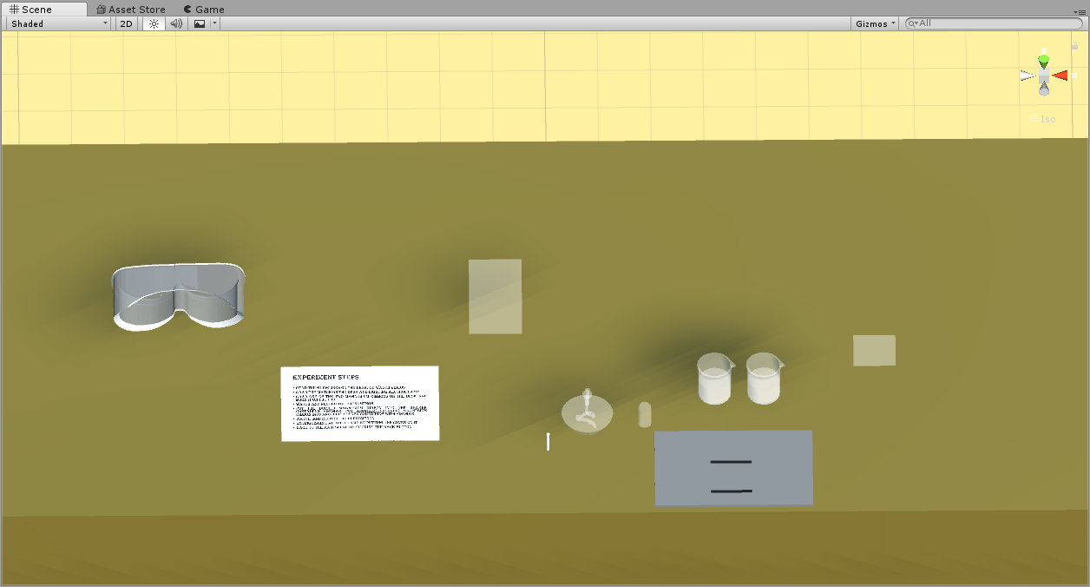

Figure 5-5. The experiment desk

5.2.1 E1 using Leap Motion

* Read the guidelines or videos on the experiment desk.
* Lighting alcohol lamp by pointing with index finger.
* Clip one of the two magnesium ribbons on the desk and burn it on the alcohol lamp.
* Watch and record the phenomenon.
* Put the burned magnesium ribbon in the beaker containing vinegar, put another(unburned) magnesium ribbon into a beaker containing vinegar.
* See and record the phenomenon.
* Extinguishing alcohol lamp.

5.2.2 E1 using Oculus HMD

The first step is to actually put on your Oculus HMD and hold the handle Controllers on your hands. After that, it's free reign over lab experiments. For example, it's completely possible for the user to grab a paper that show the introduction on it or a match, and then place the match stand on the alcohol burner, the alcohol will be on fire, place the magnesium rods on the fire, and watch the phenomenon.

* Use the Touch Controllers Choose the Experience1 in main scene and press Go button
* Read the guidelines on the desk or videos
* Grab the match on the desk and Lighting alcohol lamp
* Clip one of the two magnesium ribbons on the desk and burn it on the fire.
* Watch and record the phenomenon.
* Put the burned magnesium ribbon in the beaker containing vinegar, put another(unburned) magnesium ribbon into another beaker containing vinegar
* Watch and record the phenomenon
* Extinguishing alcohol lamp by put the cover onto the alcohol lamp
* Back to the Main scene by clicking the “Back to Main” button
  1. 5.3 Implementation

5.3.1 Leap Motion

Although Leap Motion currently does not support connected to the PC directly, the way to achieve Leap Motion and PC connection is through the wireless network protocol, the PC side as the server, the mobile as the client, running the program on the PC and the mobile phone at the same time, gesture recognition information passed the network protocol is transmitted to the PC for processing. Although this method realizes wireless connection and the mobile phone has certain mobility, it still cannot get rid of the PC. In my project, the application is directly run in Unity and connect to mobile phone with Unity Remote which is a downloadable app designed to help with Android, iOS and tvOS development. The app connects with Unity while you are running your project in Play Mode from the Unity Editor. When use Leap Motion as the interaction tool, users’ hand is recognized as the Figure 5-6.



Figure 5-6. Hand control with Leap Motion

First, set up three scenes. Then, download and install LeapMotion Setup. We use the Leap Motion Unity package “LeapMotion\_CoreAssets \_4.1.6.unitypackage”, Unity version 2017.1.1, To use the latest Unity development kits the version need to be 5.5 or later, otherwise it will give an error. Import the LeapMotion SDK to the project. Create a hand model by draging the prefab LeapHandController to the scene (hand controller supported by LeapMotion), Then drag the prefab “CapsuleHand\_L” and “CapsuleHand\_R” to the scene (without physical properties), then the hand with physical properties should be placed in the scene, there is a HandModelsPhysical folder under the HandModelsNoHuman file Drag RigidRoundHand\_L and RigidRoundHand\_R inside the scene, so that the hand is created in order to facilitate management, we create an object in the scene to manage the four hands we just created, create an empty object named HandModels in the scene, and use the hand we just dragged the prefabs on HandModels as its children. As shown in Figure 5-7. set the LeapHandController datas the inspector panel, find the HandPool component, assign HandModels to ModelsParent, and find that set ModelPool’s size to 1.



Figure 5-7. LeapHandController prafebs

[Define some gesture](javascript:;)s that can interact with the object more accurate, such as lighting the alcohol lamp by pointing (with one index finger) the top of the alcohol lamp, shown in Figure 5-9, the index finger has been selected to do this point, so that the Finger State was set to “Extented” as Figure 5-8 (right). When start the experiment, light the Alcohol by pointing with the index finger, shown in Figure 5-9.

 

Figure 5-8. [Definition of hand gesture](javascript:;)s



Figure 5-9. Light the Alcohol fire by pointing

Creat LeapMotionMain.cs script that control the generate of the Magnesium Rods and drag it to the Main gameobject. Detects the contact between the magnesium ribbons and the alcohol lamp by TriggertEnter () and ignite the magnesium ribbons.

private void TriggertEnter(GameObject arg1, Collider arg2)

{

if (arg2.transform.parent.tag == "GameObject")

{

if (arg2.transform.parent.gameObject == MagnesiumRod)

{

if (MagnesiumState == false && MagnesiumIsFire == false && alcoholLampIsFire)

{

MagnesiumState = true;

this.ExecuteLater(() =>

{

if (MagnesiumIsFire == false && MagnesiumState == true)

{

MagnesiumFire.SetActive(true);

MagnesiumIsFire = true;

DOTween.To((float scaleX) =>

{ MagnesiumRod.transform.GetChild(0).GetComponent<MeshRenderer>().material.mainTextureOffset = new Vector2(1-scaleX / 2, 0.0f); }

{ MagnesiumIsFire = false;

MagnesiumFire.SetActive(false);

}

MagnesiumState = false;

}

}

}

5.3.1.2 Implementation Result using Leap Motion

The project has three scenes, Figure 5-10(a) is the main menu scene, that allow users choose the mode, Figure 5-10(b) is the AR mode scene, here we use simple geometries as the Atomic structure model, Figure 5-10(c) shows the VR mode scene, that interact the chemical apparatus by hands with LeapMotion.

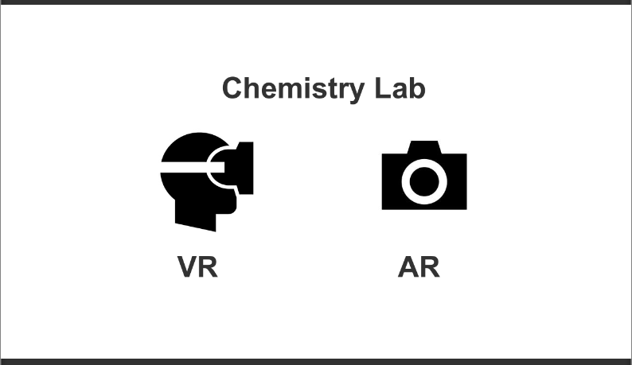

(a) Main Menu

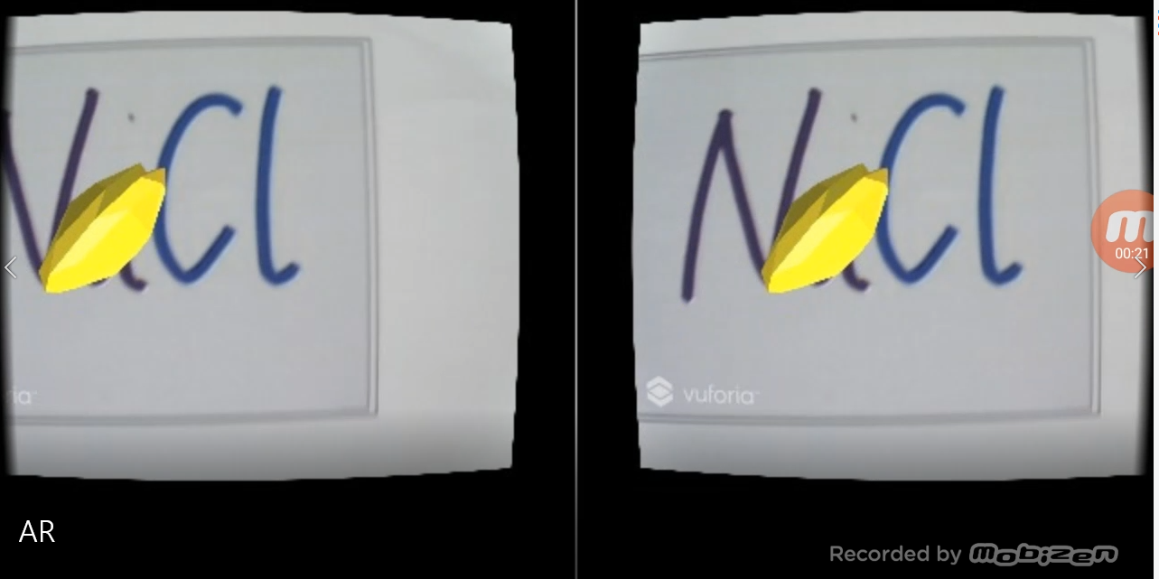

(b) AR scene



(c) VR Scene

Figure 5-10. MR Chemistry Lab Scenes

5.3.2 Oculus HMD

When use Oculus Controller as the interaction tool. The Controller are called Touch Controller, they are corresponding to the left and right hands, each handle has two buttons, a remote controller, a touch panel, and two trigger buttons shows in Figure 5-11. The left controller has a menu button, which is used to pause the game. In the game, the right controller has a main interface button, which is used to exit the game interface and return to the Oculus main interface. Each key has a corresponds name for coding, shown as follow Figure 5-11.



Figure 5-11. Oculus Hand Controllers [63]

During the experiment, grab operation is controlled by manipulating “Axis1D. PrimaryHandTrigger”, and use the “Axis2D.PrimaryThumbstick” to get the zoom in and out of the object as shown in Figure 5-11, select the menu through the rays released by the Touch Controllers, and then click the button Button.One to confirm.

Download the corresponding components on the Oculus Developer Center website, Oculus Utilities for Unity, Unity 4 Legacy Integration, Oculus Avatar SDK, and Oculus Platform SDK and import these four components into Unity project, find the “OVRCameraRig” prefabs and drag into the hierarchy view. The magnesium ribbons are controlled by the “Meitiao.cs” script as follows, the states of the magnesium ribbons can be recorded in isFire, and the magnesium ribbons’ color (it turns white while it is burning) are controlled by the offsetControll value of the MeshRenderer Material of the magnesium ribbons.

bool isFire

bool isFired

GameObject fire;

MeshRenderer offsetControll;

isFired = false;

SetFire(isFire);

if (isFire)

{

float deltaTime = Time.deltaTime \* 0.33f;

offsetControll.material.mainTextureOffset += new Vector2(0.5f, 0) \* deltaTime;

fire.transform.localPosition += fire.transform.right \* deltaTime;

if (fire.transform.localPosition.x >= 0.5f)

{

SetFire(false);

isFired = true;

}

}

public void SetFire(bool active)

{

isFire = active;

fire.SetActive(active);

}

ChemFire.cs control the fire of the alcohol lamp’s fire, the match , cover and the magnesium ribbons can be detected by OnTrggerEnter().

if (other.gameObject.tag == "match")

{

\_fire.SetActive(true);

isFire = true;

}

if (other.gameObject.tag == "meitiao1" && isFire)

{

Meitiao meitiao = other.GetComponent<Meitiao>();

if(!meitiao.isFired)

meitiao.SetFire(true);

}

if (other.gameObject.tag == "cover")

{

other.GetComponent<Rigidbody>().isKinematic = true;

other.transform.position = new Vector3(0.0616f, 1.1169f, -0.7143f);

other.transform.eulerAngles = new Vector3(-90, 0, 0);

\_fire.SetActive(false);

isFire = false; }

5.3.2.2 Implementation Result using Oculus

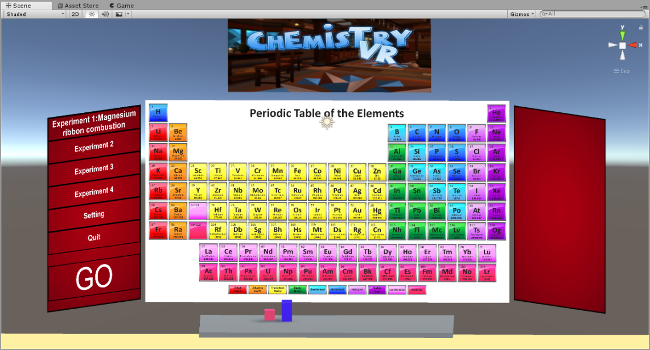

(a) Main UI scene

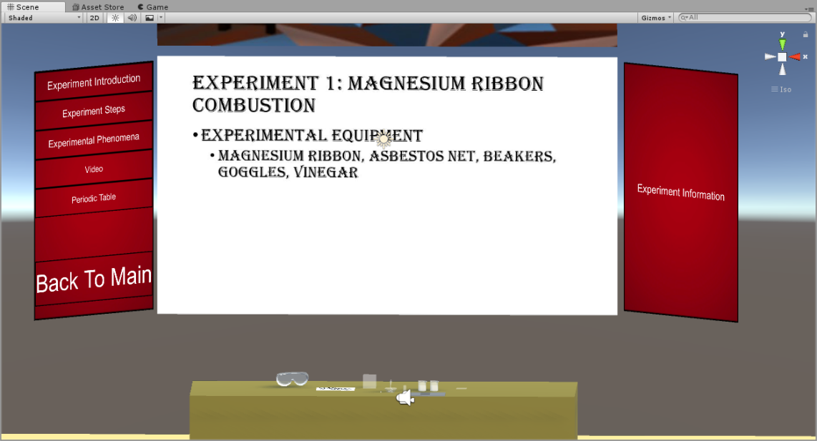

(b) The UI in experiment scene

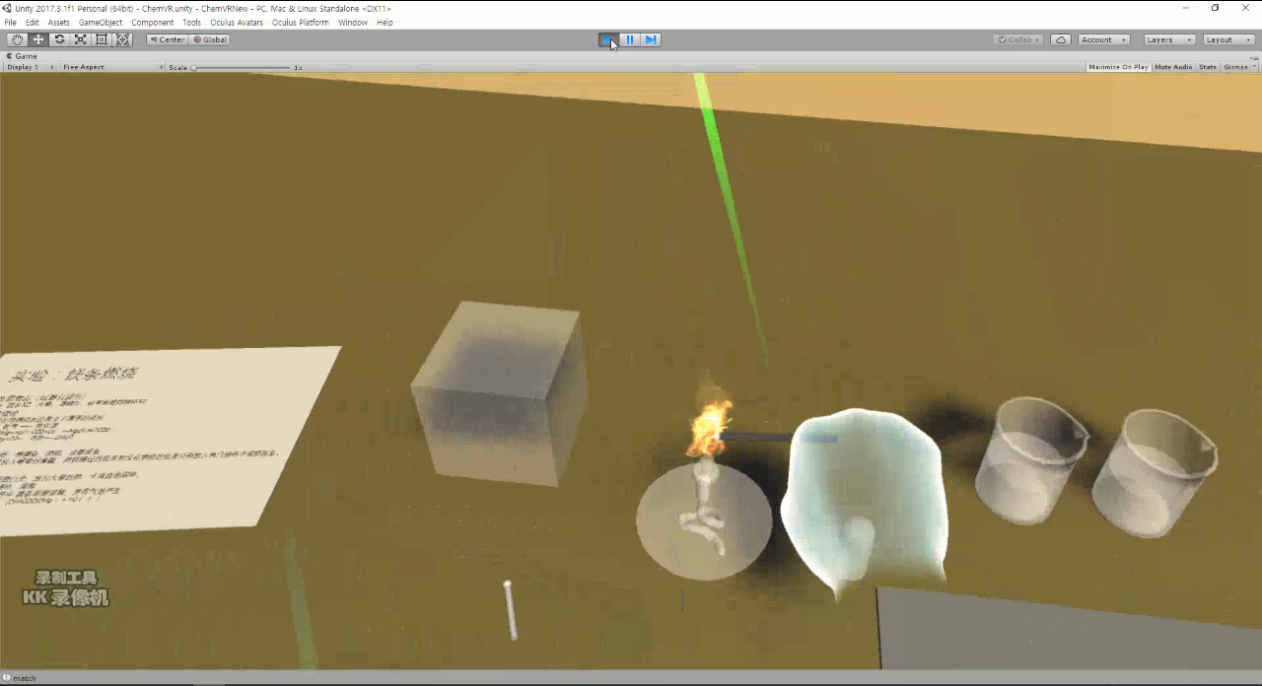

(c) The experiment scene

Figure 5-12. Chemistry lab experiment scenes

* 1. 5.4 Conclusion

Chemistry is a highly practical subject relying on experimental teaching. In the teaching process, most of its teaching information is transmitted through experiments. However, a considerable portion of experiments in chemical experiments are dangerous (such as the hydrogen experiment). Or the experimental phenomenon is not easy to observe (such as lipidation reaction, nuclear electron movement state). Therefore, through the aid of the auxiliary means to reduce the disadvantages of the traditional experiments, thereby increasing the experimental effect on the promotion of learning has become an increasingly concerned issue for researchers. As a new technology, virtual reality technology can simulate and emulate the content of experiments. It can not only increase students' perceptual knowledge, but also improve their hands-on ability. It can also save experimental costs and reduce experimental harm. The advantages of virtual reality technology will provide a new learning method and learning environment for the experimental disciplines in the education field, especially in education.

Through the virtualization of chemical experiments, the danger of reducing chemical experiments has been achieved; chemical reagents have been saved; and the time and space limitations of students when doing experiments have been broken. In the virtual laboratory, students can both operate on virtual test benches and design their own experiments, which is conducive to cultivating operational capabilities, analyzing diagnostic capabilities, design capabilities, and innovation awareness. In the virtual laboratory, students are more likely to acquire relevant knowledge. Compared with traditional laboratories, students change from passive listening to active inquiry learning. The chemistry experiment teaching mode is usually a student preview, the teacher gives a live explanation, and the student conducts experiments again. Students can only memorize mechanically, operate mechanically, and lack the initiative and enthusiasm for learning during the entire experiment. In the virtual chemistry laboratory, the microcosm of the world can be understood through the sensory experience of sound, picture, and text. It stimulates interest in learning and integrates knowledge and interest through interactive functions and simulation techniques. Virtual laboratory equipment is zero-consuming and non-polluting. In conventional chemical experiments, large amounts of pharmaceuticals and water resources are inevitably required. The experimental process is accompanied by toxic gases, waste water, and harmful substances. For example, when studying sulfur, The SO2 formed by oxygen reaction is the main component of acid rain formation. If it is directly emitted into the atmosphere, it will pollute the environment. The virtual chemical laboratory does not suffer from wear and tear, and it can be used repeatedly without consuming drugs. Importantly, the educational effect is not better than actual. Poor teaching. The experiment is efficient and saves time. The virtual laboratory saves many preparations for real experiments, allowing the experiment to focus on the characteristics and laws of the experimental subjects themselves. The microscopic view is macro and the abstraction is concreted, such as atoms. structure.

Although mixed reality was used in chemical experiments, breaking many of the limitations of traditional teaching and achieving the desired teaching effect, the accuracy was not high when interacting with interactions, such as using LeapMotion. The inherent shortcomings of hardware equipment, such as the Oculus HMD dizzy after long wear problems, the diversity of experimental equipment, the experimental phenomena of fidelity there is still much room for improvement. With the development of the times, especially in the advancement of computer technology and computer graphics technology, augmented reality technology will continue to be improved. It is believed that in the future learning and practice, these issues will be perfected and overcome, virtual reality. Technology will bring a new look to the field of chemistry experiment teaching and will continue to seek new methods that can promote the optimization of the quality of chemistry experiment teaching to enhance learners' learning ability and creativity.

1. . Evaluation

Education game is a kind of computer game full of game specialty and educational utility. In essence, education game belongs to kind of computer software which carries forward education and entertainment purposes produced by game designers and producers. Education game evaluation, as an important link in game design and development process, has certain guiding role. Effective evaluation for education game is a forceful guarantee in the development of education game. For developers, they could refer to a criterion which pertinently develops education games and meantime saves time and costs. For teachers and students, they could quickly find a teaching-assistance game to mobilize learning interests. For parents and schools, they could eradicate traditional prejudice against game and establish scientific education attitudes. According to Warren Buckleitner, children and technology expert from America, gamification learning software is three-dimensional. In addition to the evaluation on quantity (quantity of tasks) and quality (story and animation), evaluators should also make judgment for the interaction control of children in software application process and the definition of menu design. Evaluation on software experience feelings is akin to the evaluation on teacher-student interaction. Actually, the opinion of Warren Buckleitner happens to coincide with constructivism learning theory. Constructivism emphasizes the role of meaning construction and socio-culture interaction in learning and highlights the situation of knowledge learning and intelligence in view of the function of situation in knowledge synthesis via activities. As a result, learning ought to take place in a situation similar to the real scene. Virtual reality (VR) and augmented reality (AR) education game could provide a real and open situation for learners and encourage students to actively explore and solve all sorts of problems.

The purpose to apply VR and AR technology in education game design is primarily to construct a virtual learning environment or a learning situation which combines virtuality with reality. How to build up an effective learning environment is a problem to be concerned in the beginning of design. Schank and Kass [64] conclude three elements of effective learning environment. The first one is to present a goal that could motivate the momentum of learners. The second one is to place learners in a real learning environment. The last one is to designate tasks that demand learners to analyze information and design action plan. In combination with the game cases and relevant theories mentioned above, it could be found that goal incentive, real situation construction, timely and effective feedback constitute the key in education game design. In addition, attention should be also paid to the security evaluation of VR and AR education game in teaching design link to ensure the personal security of game experiencers.

Textbooks and the general web provide information based on text and two-dimensional images. In contrast, the virtual world provides a 3D-based three-dimensional educational environment, which has various educational advantages [65]. The following table is a summary of the educational benefits that virtual worlds can provide by summarizing and complementing existing research on the effects of virtual world education [66].

Table 6- 1:Educational advantages according to characteristics of virtual world

|  |  |
| --- | --- |
| Items | Contents description |
| Specific experience | The virtual world provides multi-sensory information so learners can experience the situation directly |
| Presence | The virtual world helps learners to immerse themselves in making users aware of their presence and influence |
| Sharing experiences | Activities in the virtual world encompass social aspects and provide opportunities to experience different cultures |
| Cooperativeness | In the virtual world, users can form groups to help others or to achieve their goals, which is the basis for cooperative learning |
| Flexible environment | The environment of the virtual world can be optimized for learning objectives and continuous updates provide the latest information to learners |

* 1. 6.1 Evaluate System

The goal of education game evaluation is to judge the facilitation role of education game in learning as a kind of learning instrument, namely full excavation of the educational values of education game. Alvaro, Chief Research Institute in Non-profit Education Research and Development Institution and Babette, Researcher in Children and Family Member Center tease the document literature concerning gamification learning environment evaluation, concluding that the evaluation on the progressive program of digital gamification learning environment includes the following five procedures as shown in the following table [67].

Table 6- 2: Five Steps for Digital Gamification Learning Environment Evaluation

|  |  |
| --- | --- |
| Procedures | Specific description |
| Step One | To acquire software by purchasing or obtaining demo and account and win evaluation permit |
| Step Two | To satisfy software operation hardware condition, clarify education purpose and target users, help realize learning goal and establish non-gamification learning environment |
| Step Three | To analyze the means of software evaluation in other organizations for reference |
| Step Four | To invite target users to try the software and conduct questionnaire and interview with them after the completion of experience |
| Step Five | To conduct further analysis with evaluation gauge |

Another similar case is 80days digital education game project group’s evaluation on education game. They are not confined to the games that have been already developed and put into use. Instead, they make tracking evaluation on education game in every stage from design to development and application and combine formative evaluation with summative evaluation. First of all, the research conducts questionnaire survey to gain children’s acceptability for this game design targeted at game design concept prototype; secondly, it organizes expert examination on game usability and playability in game development and operation and excludes numerous problems in game design and development process; thirdly, it selects a school in Britain and Australia as the user groups for test, including usability, user experience and teaching effects; eventually, it raises questions and carries out focus group interview according to conclusions [68]. The evaluation process employs questionnaire survey method, expert examination method, experimentation method, interview survey method, quantitative evaluation method and qualitative evaluation method. Referring to the characteristics of the game produced in the thesis, the evaluation procedure mainly uses comparative method, questionnaire survey method, interview method and gauge measurement method.

6.1.1 Educational Game Evaluation Gauge

Evaluation gauge is a real evaluation instrument made up of a series of indicators. It is a set of standards made to evaluate the characteristics of education game or evaluate the grade of the education game. At the same time, it is also an important bridge which connects the development, application and evaluation of education game. As a matter of fact, applying gauge in education game evaluation belongs to a kind of indicator quantitative evaluation method. The application of evaluation gauge in the evaluation of education game is very feasible and easy. By changing the indistinct and ambiguous evaluation contents of some education game evaluation methods, it disintegrates evaluation contents into several specific programs with strong operability and short duration. The following table arranges some evaluation gauges suitable for teachers, parents or game developers and designers closely related to education game.

Table 6- 3: Educational Game Evaluation Gauge Research

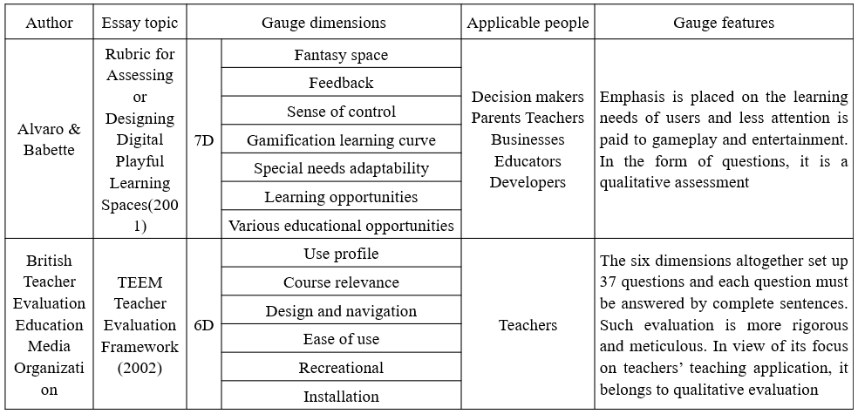

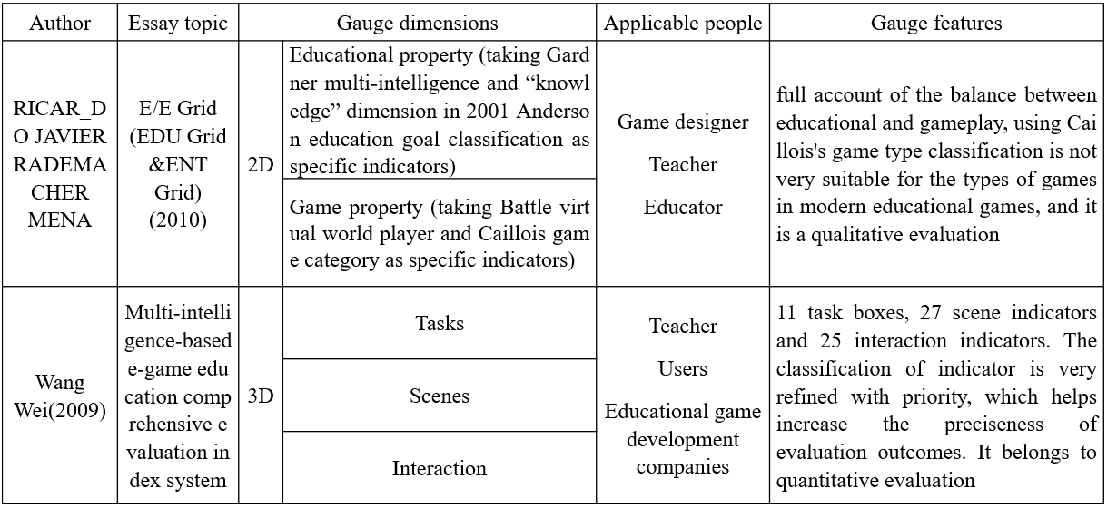

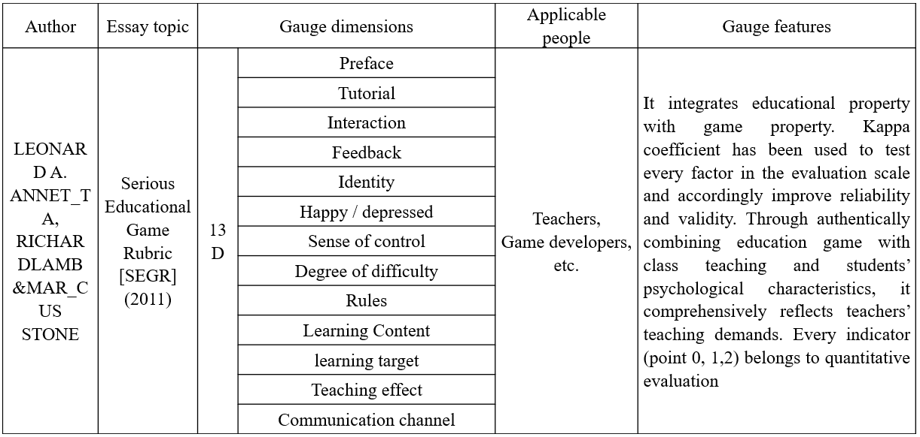

The multi-intelligence computer game evaluation gauge proposed in the innovative research of Wang Wei (2010) [68] illustrates the influence of computer game on the multi-intelligence of teenagers as the benchmark and classifies computer game into eight categories such as language-type computer game and music-type computer game. Meanwhile, each category has been matched with a specific evaluation gauge labeled with weight. At present, there exist all sorts of education games. In view of their respective distinctive characteristics, it is hard to adopt the same gauge to give correct evaluation on these characteristics. After all, only games in the same category have comparability. Combining with the characteristics of each evaluation system summarized in last section and the characteristics of VR education games, the research presents the evaluation system with five gauges dimensions including equipment cost performance, portability, user experience, education effects in the Table 6-2. Among these dimensions, cost performance and portability could be directly recorded and compared as the intrinsic properties of equipment, user experience and education effects need to be verified by test or question, while experience feelings and education effects should be evaluated by oral interview. Three games mentioned in the research all belong to VR and AR education game. One of the distinctive characteristics of such games consists in the immersive sense. Therefore, it is a necessity to experience the gauge of immersive sense and control sense. However, the research primarily focuses on qualitative analysis, but lacks quantitative analysis. Oriented towards the characteristics of VR and AR programs and two target groups stated above, the research designs and selects the following evaluation gauge Table 6-4. Among three applications in the research, 3D coloring game is a game designed for preschool-age children, while chemistry lab and art exhibition are games designed for colleges. In consequence, the evaluation system is grouped into 3 groups, namely VR Art Exhibition group and 3D Coloring Game and MR Chemistry Lab group. Different evaluation means should be adopted in line with different age groups.

Table 6- 4: Gauge Dimension Design of Evaluation System in the Research

|  |  |  |  |
| --- | --- | --- | --- |
| Gauge Dimensions | Evaluation Method | | |
| VR Art Exhibition | AR 3D Coloring Game | MR Chemistry Lab |
| Hardware Equipment | Comparative | Comparative | Comparative |
| Immersive | Interview | Interview | Interview |
| Educational Effects | Interview & Expert examination | Questionnaire & Expert examination | Questionnaire & Expert examination |
| Interaction Control | Interview | Interview | Comparative & Interview |
| Degree of Difficulty | Interview & Expert examination | Interview & Questionnaire | Questionnaire |

However, it is still less comprehensive by simply employing evaluation gauge in the judgment on education game application values. Actually, evaluators also need to investigate learners’ learning behaviors and change of learning effects after the use of education games so as to make more rational and all-round evaluation. Among overall gauges in investigation, education effects fabricate the foremost gauge which could reflect whether the evaluated application has reached expected education purposes. This is also the original purpose for the researcher to design and develop the game or application. The three applications developed in the thesis also have their respective explicit education purposes shown as the following table 6-5.

Table 6- 5: Education Purposes and Target Objects of Each Game in the Application

|  |  |  |  |
| --- | --- | --- | --- |
| Game Project | Target Object | Education Degree | Educational Goals (Effects) |
| VR Art Exhibition | 20 years old | College | To appreciate art works anytime and anywhere |
| AR 3D Coloring Game | 6 years old | Pre-school | To recognize the Earth and solar system. Cultivate children’s color identification and hands-on skills |
| MR Chemistry Lab | 20 years old | College | To learn chemical experiments, familiar with experimental procedures and observe experimental phenomena and the microscopic atomic structure |

Obviously, AR 3D Coloring Game more aims at the development of infant potentials and the stimulus of learning interests, VR Art Exhibition allows users to repeatedly appreciate and deliberate art works, and beyond all doubt, MR Chemistry Lab enables students to exercise chemical experiment procedures and deepen the impression on the microscopic atomic structure and experimental phenomena.

* 1. 6.2 Evaluations for the 3 cases

Educational experiment method is a universal research method in education game research. Throughout the comparative experiment, the research generally probes into the role of education game in learning effects. The setting of experimental group and comparative group intends to compare the influence of control variables on learning effects. In general cases, the comparative group is traditional learning or common online learning method, experimental group sets up one or more groups, multi-experimental groups further explore the influence of VR or AR technical application category, degree or feedback on learning effects. In this research, AR 3D Coloring Game and VR Art Exhibition set up a comparative group, and MR Chemistry Lab sets up two experimental groups. Both pre-test and after-test are used to measure the promotion degree of learners’ learning effects, scientifically prove that the change of learning effects results from the adoption of certain teaching method or technology and verify the consistency of experimental objects’ learning level in the two tests. In case of any significant discrepancy in learners’ learning level in pre-test and after-test, high-low score group could further inquire the varying promotion role of education game on different students.

In this research, the researcher chooses experimental objects with proper age and knowledge mastery degrees. In this sense, it is no need to divide the high-low score group. After-test measures learners’ learning transfer and effects maintenance, while attitudes test and motivation test collect experimental objects’ attitudes and suggestions for education game and help researchers and education practitioners improve game design and teaching design. Open questionnaire allows the experimental objects to more flexibly express their thoughts and feelings. Apart from the use of questionnaire, the researcher also combines with classroom observation method and interview method to collect more information for the analysis on measurement results if permitted. As introduced in the last section, because the three application programs respectively target at the research objects in different age groups, 3D coloring game and VR Art Exhibition divide one experimental group and comparative group with each group having 15 members in different genders. While VR Chemistry Lab test tasks proceed in Leap Motion experimental group, Oculus HMD experimental group and comparative group. In discipline expansion education, 45 experimental objects are all chosen from college students aged around 20 in different genders. Objects in the experimental group implement the program developed in the thesis, and objects in the comparative group and experimental group receive the same traditional teaching mode. Please refer to the following Table 6-6 for grouping conditions.

Table 6- 6: Experimental Subjects and Groups

|  |  |  |  |  |  |  |  |
| --- | --- | --- | --- | --- | --- | --- | --- |
| Game | AR 3D coloring game | | VR art Exhibition | | MR Chemistry Lab | | |
| Group | Experimental Group | Comparative Group Normal | Experimental Group | Comparative Group Normal | Leap Motion Experimental Group | Oculus HMD Experimental Group | Comparative Group |
| Number | 15 | 15 | 15 | 15 | 15 | 15 | 15 |
| Total | 45 | | 30 | | 45 | | |

6.2.1 VR Art Exhibition Evaluation

Evaluation subject in this section is VR Art Exhibition, an application developed for art department college students. Corresponding evaluation contents include the appreciation of art works’ experiential feelings. In the meantime, users could repeatedly appreciate and deliberate art works without any doubts by way of virtual art exhibition.

* **Experimental Objects**

The evaluation chooses 30 art department college students, including 15 male college students and 15 female art department college students, and 2 teachers from the arts department.

* **Research Design**

Users in the experimental group utilize VR equipment in art exhibition appreciation, while experimental objects in the comparative group go to the real art exhibition scene to appreciate art works and later give evaluation.

* **Experimental Results**

In this evaluation, we use Google Cardboard and Android Phones, shown in follow Figure 6-1.

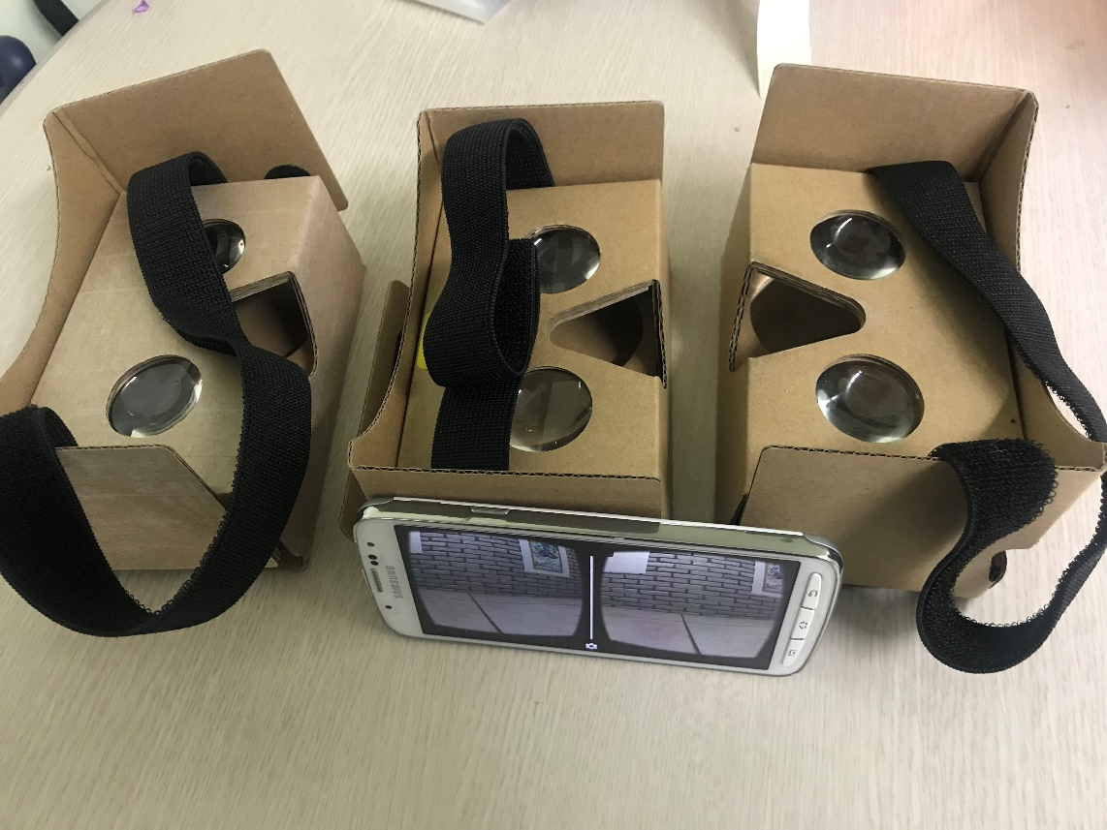

Figure 6- 1: The VR art exhibition evaluation using Google cardboard and Android phone

According to our evaluation system designed in the previous section, the results are presented in the following Table 6-7, the results are the opinion of most people obtained through the analysis of the experimental results.

Table 6- 7: The VR Art Exhibition Evaluation Result

|  |  |  |
| --- | --- | --- |
| Gauge Dimensions | Evaluation Result | |
| [Experimental](file:///E:\youdao\Dict\7.5.2.0\resultui\dict\?keyword=experimental)[group](file:///E:\youdao\Dict\7.5.2.0\resultui\dict\?keyword=group) | Control group |
| Hardware Equipment | Mobile terminal equipment (Android Phone) | None |
| Immersive | Relatively authentic | Authentic |
| Educational Effect | Repeated appreciation at any time and space | Limit in time and space |
| Interaction & Sense of control | Easy and close to natural interaction | Natural |
| Degree of difficulty | Simple | Difficulty in implementation |

As indicated by the research results, experimental objects who have the chance to visit art exhibition scene really enjoy the appreciation process. However, there are too many visitors at the scene, and objects need to consider transportation and business time. Above all, visitors should buy the ticket for one time. As commented by objects who have used VR, they could conveniently appreciate art exhibition at any time and space. The interaction means is also very natural because visitors could nearly acquire the experiment similar to the real scene. However, the work will be distorted to some degree, which fabricates another factor that influences user immersive sense. In the future, this weak point should be modified by pertinent solutions.

6.2.2 AR 3D Coloring Game Evaluation

This evaluation aims at 3D coloring game, a VR+AR educational game developed for preschool-age children. Evaluators of the game include game developers and target users (preschool-age children). Evaluation contents include (1) the cognition effects of experimental objects in the experimental group and comparative group about Earth; (2) the emotional attitudes of experimental objects after the use of AR. Children in the experimental group resort to AR instrument to recognize Earth and resort to tintage to recognize the distribution and profile of all continents and oceans. Experimental objects are interviewed after the test. Interview questions are recorded in the appendix.

* **Experimental Subjects**

30 students in a kindergarten are divided into two groups, with 15 members in the experimental group and 15 members in the comparative group. Besides, teachers of children are also included in the research. Prior to the experiment, the researcher should guarantee that all experimental objects could familiarize with the most fundamental operation means of phones, such as button clicking.

* **Experimental Design**

Children in the experimental group know Earth by AR game, and know the appearance of Earth and the profile of continents and oceans by filling colors in pictures via the phone screen. Simultaneously, children in the comparative group learn the profile of Earth and continents with traditional teaching method which combines graphic pictures and language instruction.

* **Experimental Results**

The experiment summarizes and analyzes the interview results for children in the experimental group and comparative group. Evaluation process is shown in the Figure 6-2 below.

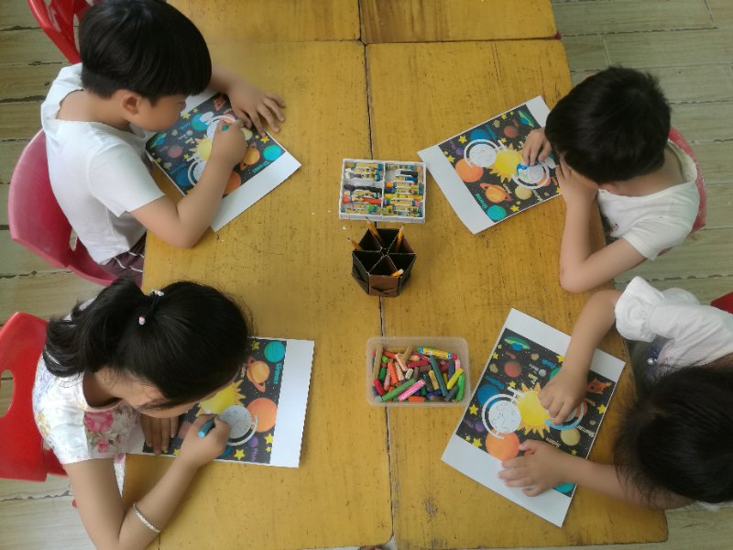

(a) The children are coloring the picture

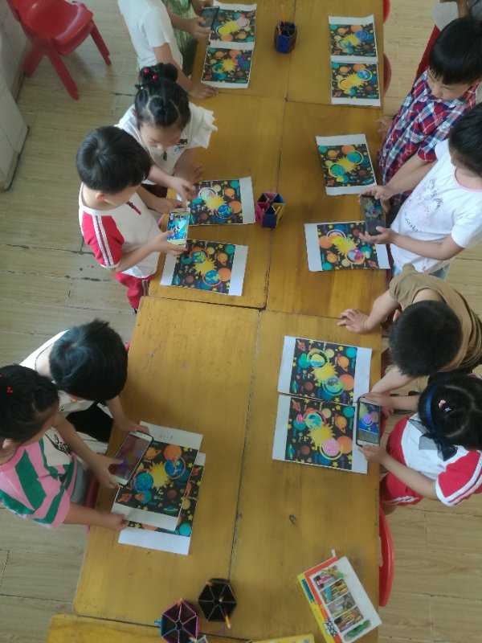 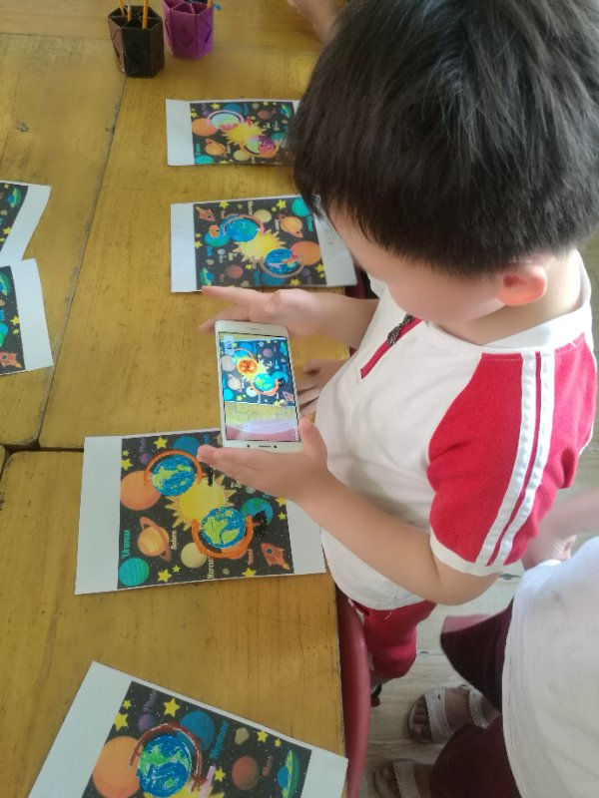

(b) and (c) Implementation on the phone

Figure 6- 2: The evaluation process pictures of the Coloring the Earth AR

According to our evaluation system designed in the previous section, the results are presented in the following Table 6-8, the results are the opinion of most children obtained through the analysis of the experimental results.

Table 6- 8: The AR 3D Coloring Game Evaluation Result

|  |  |  |
| --- | --- | --- |
| Gauge dimensions | Evaluation Results | |
| [Experimental](file:///E:\youdao\Dict\7.5.2.0\resultui\dict\?keyword=experimental)[group](file:///E:\youdao\Dict\7.5.2.0\resultui\dict\?keyword=group) | Comparative group |
| Interesting | Vivid and interesting | Dull, boring |
| Hardware Equipment | Requirements: Android phone, printed identification map. Required hardware is readily available and portable | Graphic picture display; teacher instruction |
| Educational Effect | Experimental subjects have preliminary recognition and deep impressions about Earth, continents and oceans | Experimental subjects have preliminary recognition about the tellurion, but have superficial impression on it because of the shortage of practical participation |
| Interaction & Sense of control | Simple operation mode; precise control by clicking | Natural |
| Degree of difficulty | Simple | Simple |

As proved by the results, in hardware equipment, the experimental group has relatively higher requirements on hardware equipment. Moreover, the AR technology used by the experimental group has apparently superior interest and education effects than the traditional teaching method used by the comparative group. In the aspect of interaction, AR technology helps experimental objects directly participate in interaction and deepen impression. The implementation in the comparative group appears to be simple. Since children in the kindergarten are still young and could not express their attitudes, the researcher interviews teachers of the class for having a deeper understanding about this experiment. Teachers generally hold the opinion that “such learning method integrates tactile sense and visual sense. More importantly, students are able to use their imagination to express thoughts with pens.” This means could more easily stimulate children’s learning interests and exploration enthusiasm.

6.2.3 MR Chemistry Lab Evaluation

Evaluation subject in this section is MR Chemistry Lab, a VR+AR virtual chemistry lab education game developed for college students. Researchers expect students to meet the following few goals: (1) to learn the atomic structure of different elements and unify the recognition about material macroscopic composition and microscopic composition; (2) to generalize abstract concepts and command basic chemical research method; (3) to repeatedly rehearse experimental procedures in virtual laboratory before the real experiment, in particular for experiment with hazardous articles and precious reagents for fear of potential risks and reagent waste caused by the non-familiarity with experimental procedures; (4) to deepen the impression on reaction by repeated observation; (5) to cultivate the scientific attitudes of respecting objective facts, being meticulous and prudent and activate learners’ interests in chemistry.

* **Experimental Objects**

45 students from the Chemistry Department of certain university are chosen to be experimental objects. The evaluation has two experimental groups and one comparative group, among which the Leap Motion experimental group has 15 objects, the Oculus HMD experimental group has 15 objects and the comparative group has 15 objects in different genders. Two chemical teachers participate in the evaluation. Besides, all experimental objects should familiarize with equipment and operation mode before evaluation.

* **Research Design**

Before teaching in practice, the researcher interviews with the chemical teacher. He points out that students do not hold positive learning attitudes towards the course nor totally understand relevant knowledge in learning materials. Actually, such knowledge is boring and abstract. He expects to use VR and AR technology to consolidate the learning contents through chemistry experiment and improve students’ learning effects and cultivate their positive learning attitudes. Therefore, although the experiment sets up comparative group to conduct a horizontal comparison on comparative group and experimental group, it also conducts a longitudinal comparison. For instance, pre-test scores represent students’ mastery about MR learning instruments and after-test scores represent students’ learning effects based on MR learning instruments. The longitudinal discrepancy between pre-test scores and after-test scores represents MR application learning effects. The questionnaire mainly inquires students’ emotional attitudes towards MR learning instruments.

* **Experimental Results**

The experiment summarizes and analyzes the interview results for children in the experimental group and comparative group. Evaluation process is shown in the Figure 6-3 below.

**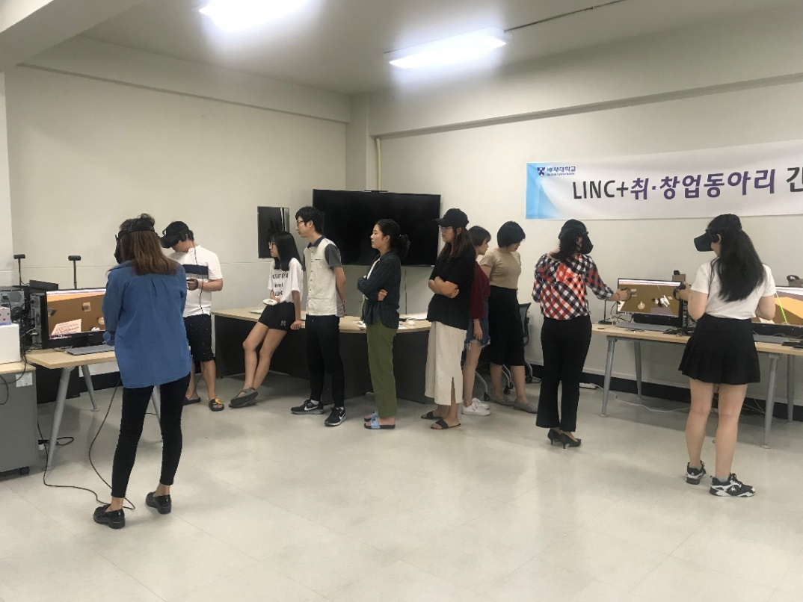**

(a) The [experimental](javascript:;) [subject](javascript:;)s are divided into groups waiting to experience

**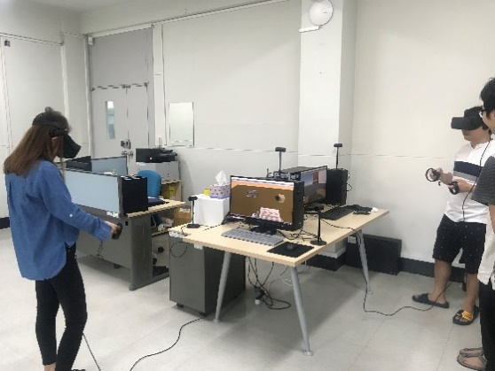 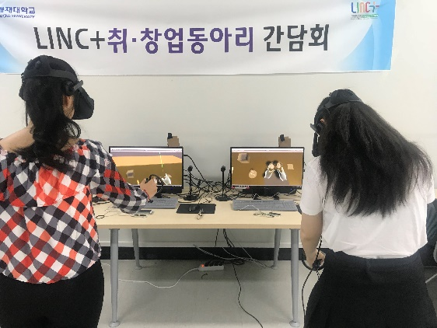**

(b) and (c) The [experimental](javascript:;) [subject](javascript:;)s experience the application

**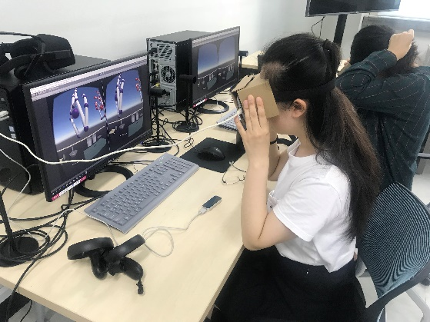** 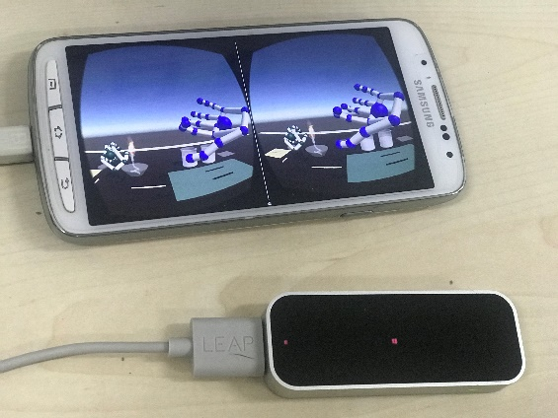

(e) The [experimental](javascript:;) [subject](javascript:;)s using the LeapMotion (f) The scene display on the phone screen

Figure 6- 3: The evaluation process pictures of the MR Chemistry Lab

Out of the limited quantity of VR equipment, the experiment is conducted by turns. According to our evaluation system designed in the previous section, the results are presented in the following Table 6-8, the results are the opinion of most children obtained through the analysis of the experimental results.

Table 6- 9: The MR Chemistry Lab Evaluation Result

|  |  |  |  |
| --- | --- | --- | --- |
| Gauge dimensions | Evaluation Result | | |
| Leap Motion [Experimental](file:///E:\youdao\Dict\7.5.2.0\resultui\dict\?keyword=experimental)[group](file:///E:\youdao\Dict\7.5.2.0\resultui\dict\?keyword=group) | Oculus HMD Experimental group | Control group |
| Hardware equipment | Leap Motion  Android Phone | Expensive, poor mobility | None |
| Immersive | Relatively authentic | Strong authentic | To operate experiment after watching teachers’ demonstration |
| Educational effect | To repeatedly exercise the flow and observe phenomena | To repeatedly exercise flow, observe phenomena and deepen impression | Unimpressive |
| Interaction & Sense of control | Poor precision and control sense | Good interactive precision and interactive control; dizziness after long time wearing | None |
| Degree of difficulty | Difficult | Relatively difficult | Simple |

Following the evaluation, the research organizes the interview with experimental objects and invites respondents to talk about their feelings about the use of learning instruments. First of all, students express that MR instrument helps them better memorize atomic structure. In traditional classroom, students could not have direct impression on abstract atomic structure under the plain instruction of teachers and their comprehension and memory persistence about knowledge might be at a low level. Whereas, MR-based software teaching could mobilize students’ initiative and encourage them to be more attentive. Once directly seeing and operating the interaction with simulation model, students naturally deepen their impression on learned knowledge. Secondly, comparing with traditional ppt or flash courseware and other 3D modeling software, MR instrument enhances students’ operability in experiment. The most important thing is that students have no need to worry about the security of reagent and experimental apparatus and overdose problems. Under this premise, repeated familiarity with experimental flow helps a lot to future real experiment. Comparing with keyboard mouse and computer operation, such direct natural interaction means has better programming knowledge memorization effects. At the same time, students also come up with some suggestions for the instrument. For instance, they desire material simulation phenomena to be more vivid and true. When being questioned that whether they want to use AR instrument in future learning, they give the unanimous answer of “yes”. As for immersive sense, the performance of two comparative groups has close performance. Since Leap Motion directly adopts gesture recognition, it is more close to natural interaction. But concerning the precision and degree of difficulty of interactive operation, Oculus HMD is apparently superior to Leap Motion. Whereas, in the evaluation gauge of education effects, the experimental group has apparently superior education effects to the comparative group. In another word, the adoption of MR technology results in better education effects.

1. . Conclusions

Virtual reality and enhanced reality technology can set up virtual learning situation for learners and help them understand learning content from various aspects. They can combine educational entertainment factors with intelligent technology factors to enhance the enjoyment of application and make it not only a tool for exhibition, observation and experience, but also a study application to help learners have a deep understanding and practice of learning content. The utilization of virtual reality and enhanced reality technology enables students to interact with the environment through bodies. “According to pedagogy including constructive learning and game-based learning, children can have best learning when they conduct it personally." Corbett said. The ability to teach experimental knowledge without leaving the classroom gives the educational experience an unparalleled value. Instead of listening to teachers, students follow the annotation with the help of headgear to get the real experience. The virtual reality education expert, Inge Knudsen, constructed a virtual building site with many safety problems. Students can walk back and forth in the virtual environment to take photos of unsafe places. Such case cannot be realized in real life, so it is especially suitable for the virtual world to make it happen. The imitation scenes enable students to experience any kind of work and life in various fields. As for the drawbacks and constraints in real-life education, they are solved and improved through virtual reality technology, so as to make the educational process interesting and attractive. In addition, the participation degree generated by virtual reality will help students’ desire of exploration to turn from entertainment at first to study and reflection in the end. As the general secretary of MissionV, Corbett, has said, “Motivation and participation are key elements of game-based learning and virtual reality uplifts the two elements to a new level.”

The combination of virtual reality and enhanced reality education will improve the teaching efficiency of future classes. The traditional teaching mode is organized by teachers to impart knowledge to students without difference, while the utilization of virtual reality technology makes personal, independent and experience-oriented teaching possible. Through individualized teaching, every student can listen to personalized teaching from teachers in the virtual environment and interact with teachers. In the traditional class, all the students listen to the same teacher, while every student has own teacher in the virtual reality class. In addition, enhanced reality technology can make static characters and pictures three-dimensional to increase the interaction, entertainment and realistic of reading and set up the real situation. Through the 3D model, the abstract learning content becomes visualized and the micro-content can be seen. The simplification of complicated learning content helps students to understand and remember abstract conceptions. When virtual reality and enhanced reality technology are applied in class as educational tools, they can present for students a communicative virtual world, where students’ sense of experience and curiosity are fulfilled and knowledge can be imparted in an innovative way. In this way, the teaching efficiency of teachers can be greatly improved, students’ learning interest will be intrigued and their learning efficiency can be enhanced.

As shown by VR and AR application cases introduced in the previous section and the latest world-famous AR game Pokemon Go, AR is more easily commercialized than VR.

There are 3 educational application cases of virtual reality technology in the foregoing chapters. In view of disciplines including design basis, education, geology and preschool education, and the result of evaluation, if the virtual reality technology is applied in the school education, the previous investment of infrastructure may be huge. However, students can have better study experience and ideal educational outcomes can basically be achieved. The virtual reality hardware devices, such as Oculus HMD, still have technical problems and there is no breakthrough. For example, vertigo can be easily caused by long term use and the hardware device of gesture recognition Leapmotion, which can interact more naturally, needs to be improved and elevated in terms of accuracy and sensibility, so as to provide sustained and lasting sense of immersion for students. Besides, according to evaluation results, we can see that, compared with virtual reality devices such as Oculus HMD, there is no need to wear heavy headgear to enhance real environment. We do not need to place special locators or define specific activity range to capture the location of users. All we need is a tablet or a mobile phone with a camera, so that we can integrate and interact in the real environment with virtual objects. As a result, the learning environment with relatively low requirement for hardware is more easily realized at school. Although it can be realized technically, the way of its combination with specific educational content needs to be designed with more efforts and time.

Compared with the study of other more mature technologies in the education, the study of application of virtual reality and enhanced reality technology in education is still at the simple and preliminary stage without deep interaction. Only a small number of cases have relatively deep interactive means. Some designs are relatively simple with a short research cycle. The sample number of quantitative research tends to be small, while qualitative research depends on the usability of learners’ self-declaration, preference and efficiency to evaluate learning outcomes. Moreover, the methods adopted is mainly based on the design study, case study and a small number of quasi-experimental research. We can see from the cases of independent research and development that most students react positively towards the virtual reality teaching tools and environment, which conforms to the research outcomes of Nunez, Quiros, Nunez, Carda and Camahort [69]. In order to provide more evidence with educational significance about AR and VR, we should control and evaluate comprehensively the study, including the collection and analysis of more samples and valuable devices. Effective after-school activities and technical characteristics should be defined in the future study of AR and VR educational application. What’s more, a set of teaching mode and the design principle of AR and VR environment should be created synthetically. In this way, guidance can be offered to problems involved with the new virtual reality learning environment.

# **References**

[1] Lu, S. J., & Liu, Y. C. (2015). Integrating augmented reality technology to enhance children’s learning in marine education. *Environmental Education Research, 21*(4), 525-541.

[2] Azuma, R. T. (1999). The challenge of making augmented reality work outdoors. *Mixed reality: Merging real and virtual worlds,* 379-390.

[3] Parisi, T. (2015). *Learning virtual reality: developing immersive experiences and applications for desktop, web, and mobile*. "O'Reilly Media, Inc.".

[4] HTC VIVE, Homepage, from https://www.vive.com/us/product/vive-virtual-reality-system/

[5] Harvey, N. (2016). Cardboard Update Brings Entire YouTube Catalogue To iPhone in VR, *URL: https://go.harveynorman.ie/technology/4992-cardboard-update-brings-entire-youtube-catalogue-to-iphone-in-vr*

[6] Luo J. L., (2016). The Ministry of Industry and Information Technology publishes a white paper on the development of Virtual Reality industry. *The age of financial technology* (10), 84-84.

[7] Kim, B. (2016). Virtual reality as an artistic medium: A study on creative projects using contemporary head-mounted displays.

[8] Yan Y. Y., (2015). The use of virtual reality technology in primary school mathematics teaching. *Teacher* (11), 34-34.

[9] Cui, N., Kharel, P., & Gruev, V. (2017, February). Augmented reality with Microsoft HoloLens holograms for near infrared fluorescence based image guided surgery. In *Molecular-Guided Surgery: Molecules, Devices, and Applications III*(Vol. 10049, p. 100490I). International Society for Optics and Photonics.

[10] Deshpande, S., Uplenchwar, G., & Chaudhari, D. N. (2013). Google Glass. *Int. J. Sci. Eng. Res, 4*, 12.

[11] Bhardwaj S., Muneshwara M. S. & GN Anil. (2016). [Survey on Converting the Virtual Reality to Augmented Reality through Holograms](http://xueshu.baidu.com/s?wd=paperuri%3A%28f9f62d4e2a773adb99d8a204c471d0f4%29&filter=sc_long_sign&sc_ks_para=q%3DSurvey%20on%20Converting%20the%20Virtual%20Reality%20to%20Augmented%20Reality%20through%20Holograms&sc_us=4425787880593313378&tn=SE_baiduxueshu_c1gjeupa&ie=utf8" \t "_blank), 4(5).

[12] Maciel, A., Roman, F., & Nedel, L. (2015). Improving Gameplay in First Person 3-D Games using Multiple Displays.

[13] Buerli, M., & Misslinger, S. (2017, June). Introducing ARKit-Augmented Reality for iOS. *In Apple Worldwide Developers Conference (WWDC’17)*(pp. 1-187).

[14] IDG. The Complete Guide to Pokémon Go, 2016. *URL: http://docdro.id/HMCbDEw*

[15] Caudell, T. P., & Mizell, D. W. (1992, January). Augmented reality: An application of heads-up display technology to manual manufacturing processes. In *System Sciences, 1992. Proceedings of the Twenty-Fifth Hawaii International Conference on (Vol. 2, pp. 659-669). IEEE*.

[16] Lee, D. (2017). Ikea Place is an AR app that lets you put furniture on the street. The Verge.

[17] Babbel, [Novica G](https://www.quora.com/profile/Novica-Gijevski). (2017, January). What is the difference between augmented reality and mediated reality. *MotivaNova.*

[18] Sheets, T. H., & Elmore, M. P. (2018). *Abstract to Action: Targeted Learning System Theory Applied to Adaptive Flight Training*. Air Command and Staff College, Air University Maxwell AFB United States.

[19] Hong X. T. (1981). *Shen Bi Ma Liang*. People's Literature Publishing House.

[20] Botella, C., Breton-Lopez, J., Quero, S., Baños, R. M., Garcia-Palacios, A., Zaragoza, I., & Alcañiz, M. (2011). Treating cockroach phobia using a serious game on a mobile phone and augmented reality exposure: A single case study. *Computers in Human Behavior*, 27(1), 217-227.

[21] Miloff, A., Lindner, P., Hamilton, W., Reuterskiöld, L., Andersson, G., & Carlbring, P. (2016). Single-session gamified virtual reality exposure therapy for spider phobia vs. traditional exposure therapy: study protocol for a randomized controlled non-inferiority trial. Trials, 17(1), 60.

[22] O'Connor, E. (2011, March). Migrating towards K12 in virtual spaces: Second life lessons learned as higher education meets middle school students. In *Society for Information Technology & Teacher Education International Conference*(pp. 2192-2198). Association for the Advancement of Computing in Education (AACE).

[23] Schank, R. C., & Kass, A. (1996). A goal-based scenario for high school students. *Communications of the ACM*, 39(4), 28-30.

[24] Jonassen, D. H. (1999). Designing constructivist learning environments. *Instructional design theories and models: A new paradigm of instructional theory*, 2, 215-239.

[25] Watson, J. B. (1913). Psychology as the behaviorist views it. *Psychological review*, 20(2), 158.

[26] Piaget, J. (1965). The stages of the intellectual development of the child. *Educational psychology in context: Readings for future teachers*, 98-106.

[27] Jonassen, D. H. (1994). Thinking technology: Toward a constructivist design model. *Educational technology*, 34(4), 34-37.

[28] S. Cai, P. W. & Wang, Y. Yang, (2016). A Survey of Educational Applications of Augmented Reality Technology. *Distance Education Magazine*, 2016, (5): 27-40.

[29] Youngblut C. (1988). *Educational Uses of Virtual Reality Technology* (No. IDA-D-2128). INSTITUTE FOR DEFENSE ANALYSES ALEXANDRIA VA.

[30] Guomin, Z., & Jianxin, Z. (2010, March). An educational value analysis of sloodle-based distributed virtual learning system. In *Education Technology and Computer Science (ETCS), 2010 Second International Workshop on* (Vol. 3, pp. 402-405). IEEE.

[31] Rester, U. (2008). From virtuality to reality-Virtual screening in lead discovery and lead optimization: a medicinal chemistry perspective. *Current opinion in drug discovery & development, 11*(4), 559-568.

[32] Prensky, M. (2001). J COMPUTER GAMES AND LEARN| NG: D 1 G ITAL GAME-BASED LEARN 1 NG.

[33] Billinghurst, M., & Kato, H. (2002). Collaborative augmented reality. *Communications of the ACM, 45*(7), 64-70.

[34] Tao J., & Li F. (2017). Research on the application of Augmented Reality technology in children's science books. *Science and Technology Information, 15*(25), 1-1.

[35] Arvanitis, T. N., Petrou, A., Knight, J. F., Savas, S., Sotiriou, S., Gargalakos, M., & Gialouri, E. (2009). Human factors and qualitative pedagogical evaluation of a mobile augmented reality system for science education used by learners with physical disabilities. *Personal and ubiquitous computing, 13*(3), 243-250.

[36] Kerawalla, L., Luckin, R., Seljeflot, S., & Woolard, A. (2006). “Making it real”: exploring the potential of augmented reality for teaching primary school science. *Virtual reality, 10*(3-4), 163-174.

[37] Cai, S., Chiang, F. K., Sun, Y., Lin, C., & Lee, J. J. (2017). Applications of augmented reality-based natural interactive learning in magnetic field instruction*. Interactive Learning Environments, 25*(6), 778-791.

[38] Kaufmann, H., & Meyer, B. (2008). *Simulating educational physical experiments in augmented reality*(p. 3). ACM.

[39] Cai, S., Chiang, F. K., & Wang, X. (2013). Using the augmented reality 3D technique for a convex imaging experiment in a physics course. *International Journal of Engineering Education, 29*(4), 856-865.

[40] Shelton, B. E., & Hedley, N. R. (2002). Using augmented reality for teaching earth-sun relationships to undergraduate geography students. In *Augmented Reality Toolkit, The First IEEE International Workshop* (pp. 8-pp). IEEE.

[41] Webster, R., & Dues Jr, J. F. (2017, June). System Usability Scale (SUS): Oculus Rift® DK2 and Samsung Gear VR®. In 2017 ASEE *Annual Conference & Exposition*.

[42] New Vision, AR School - English Learning Tool, from: http://www.new-v.com/product01.asp?typeid=9

[43] Garzotto, F. (2007, June). Investigating the educational effectiveness of multiplayer online games for children. In *Proceedings of the 6th international conference on Interaction design and children* (pp. 29-36). ACM.

[44] Aziz, F. A., Alshammar, M., & Ariffin, M. K. A. (2018). Using Virtual Reality for Equipment Maintenance in Oil and Gas Industry. *Journal of Computational and Theoretical Nanoscience, 15*(4), 1090-1094.

[45] Garris, R., Ahlers, R., & Driskell, J. E. (2002). Games, motivation, and learning: A research and practice model. *Simulation & gaming, 33*(4), 441-467.

[46] Kassem, M., Benomran, L., & Teizer, J. (2017). Virtual environments for safety learning in construction and engineering: seeking evidence and identifying gaps for future research. *Visualization in Engineering, 5*(1), 16.

[47] Wu, H. K., Lee, S. W. Y., Chang, H. Y., & Liang, J. C. (2013). Current status, opportunities and challenges of augmented reality in education. *Computers & education, 62*, 41-49.

[48] Zhang, Y., Liu, S., Tao, L., Yu, C., Shi, Y., & Xu, Y. (2015, April). ChinAR: Facilitating Chinese Guqin Learning through Interactive Projected Augmentation. In *Proceedings of the Third International Symposium of Chinese CHI* (pp. 23-31). ACM.

[49] Dix, A. (2009). Human-computer interaction. In *Encyclopedia of database systems* (pp. 1327-1331). Springer US.

[50] Myers, B. A. (1998). A brief history of human-computer interaction technology. *interactions, 5*(2), 44-54.

[51] Koutek, C. D. M., & Koutek, M. (2003). Scientific visualization in virtual reality: interaction techniques and application development.

[52] Wren, C. R., Azarbayejani, A., Darrell, T., & Pentland, A. P. (1997). Pfinder: Real-time tracking of the human body. *IEEE Transactions on pattern analysis and machine intelligence, 19*(7), 780-785.

[53] Duchowski, A. T., Shivashankaraiah, V., Rawls, T., Gramopadhye, A. K., Melloy, B. J., & Kanki, B. (2000, November). Binocular eye tracking in virtual reality for inspection training. In *Proceedings of the 2000 symposium on Eye tracking research & applications* (pp. 89-96). ACM.

[54] Kim, Y., Kim, H., Kim, Y., & Choi, J. (2017). Estimation of Willingness to Pay for Virtual Reality Theme Park.

[55] Loughran, J. (2017). Virtual reality: 5G headset coupled with full-body suit promises complete virtual immersion. *Engineering & Technology, 12*(3), 13-13.

[56] Lelyveld, P., & Entertainment, U. (2015). Virtual reality primer with an emphasis on camera-captured VR. *SMPTE Motion Imaging Journal, 124*(6), 78-85.

[57] Yang, J. N. (2015). World's first virtual reality art exhibition with Tilt Brush.

[58] Butcher, P. W., Roberts, J. C., & Ritsos, P. D. (2016). Immersive Analytics with WebVR and Google Cardboard. *Posters of IEEE VIS*.

[59] Kim B. T. (2014). “The glimmering of an idea”, 2014 International Invitation Exhibition of KDAA.

[60] Kim B. T. (2015). “Emit a brillant light”, 2015 International Invitation Exhibition of KDAA.

[61] Kim B. T. (2013). “Poseidon”, 2013 International Invitation Exhibition of KDAA.

[62] Galvis, A., Bos, N., & Tsikalas, K. (2013). Rubric for assessing or designing playful learning spaces.

[63] Oculus, V. R. (2012). Oculus rift-virtual reality headset for 3D gaming. *URL: http://www. oculusvr. com, 1*.

[64] Schank, R. C., & Kass, A. (1996). A goal-based scenario for high school students. *Communications of the ACM, 39*(4), 28-30.

[65] Bricken, M. (1991). Virtual reality learning environments: potentials and challenges. *ACM SIGGRAPH Computer Graphics, 25*(3), 178-184.

[66] Mikropoulos, T. A., & Strouboulis, V. (2004). Factors that influence presence in educational virtual environments. *CyberPsychology & Behavior, 7*(5), 582-591.

[67] Shen J., Zhang S. J. (2016). Commentary on Educational Game Evaluation Methods. *Distance Education*.

[68] Zhuang K. J., He B. X. (2013). Mixed Methods: The Ideal Paradigm for Educational Game Evaluation Research. *Software Guide, 1* (3),189-190.

[69] Núñez, M., Quirós, R., Núñez, I., Carda, J. B., Camahort, E., & Mauri, J. L. (2008, July). Collaborative augmented reality for inorganic chemistry education. In *WSEAS International Conference. Proceedings. Mathematics and Computers in Science and Engineering*(Vol. 5, pp. 271-277). WSEAS.

[70] SHI, Y., WU, C., & CHEN, Y. (2016). Study on discipline construction of materials-caused disaster chemistry. *China Safety Science Journal, 9*, 004.

교육용 혼합 현실 프로그램 개발 및 평가

단효운

지도교수 김수균

배재대학교 대학원 게임 멀티미디어 공학과

최신 컴퓨터 기술과 전통 교육 방식에서의 장단점을 상호 보완하는 문제는 교육 연구자 및 일선 교육현장에서 일하는 교육자들이 고민하는 문제이다. 현재 가상현실 및 증강현실은 수많은 영역에서 사용되고 있기 때문에 이러한 최신 기술을 교육에 접목시키는 것이 본 논문의 연구 목적이다. 특히 교육에서의 가상현실 및 증강현실 기술은 학생들로 하여금 수동적인 학습 과정으로부터 능동적인 체험 과정으로 전환하여 학습을 진행하게 된다. 위 두가지 기술은 시뮬레이션 환경을 강조하며, 사용자의 체험을 학습에서 사용할 수 있게 된다. 혼합현실은 가상현실과 증강현실의 두 가지 기술의 특징을 융합시킨 것으로, 본 논문에서는 가상현실 및 증강현실의 중요 기술을 이용하여 교육 과정에서 필요한 응용 소프트웨어를 개발한다.

본 논문은 다음과 같은 내용으로 구성되어 있다. 가상현실 및 증강현실기술이 교육에서 사용할 수 있도록 3개의AR/VR교육용 응용 소프트웨어를 개발하는 과정을 소개한다. 1장과 2장은 두 기술의 역사와 응용 및 종류에 대해 분석하였다. 그리고 다음으로는 3개의 응용 소프트웨어 제작과정에 대해 상세히 설명한다. 3장은VR Art Exhibition이고，4장은 AR 3D Coloring Game이며, 5장은 MR Chemistry Lab에 대한 개발 과정 및 분석에 대한 내용을 설명한다. 마지막으로는 사용자 평가를 통하여 본 응용 프로그램의 교육적 효과, 하드웨어 장비 특성, 인터랙션 컨트롤 방식 및 사용자 체험감 등에 대한 평가 결과를 수행한다. 이러한 평가 결과를 토대로 혼합 현실에 대한 교육에서의 유용성을 찾을 수 있다.

**키워드**: 가상 현실, 증강 현실, 혼합 현실, 교육 응용, 체험 및 상호 학습, 게임 기반 학습 응용

Acknowledgement

During the study period of master and doctoral program in the Department of Game Multimedia Engineering in PaiChai University. I studied game development knowledge and skills systematically, focused on the research of educational game and the application of Virtual Reality and Augmented Reality in educational field. I’m about to graduate. I want to thank those who gave me great help.

First of all, I have to say thank you to my advisor Prof. Soo Kyun Kim, his knowledgeable and rigorous scholarship has motivated and spurred me deeply. In the learning period of master and doctoral program, not only for the patient instruction but also for helping me apply for the scholarships, providing me with the required equipment and books, all of these created a strong academic and practical platform for me. Here, I would like to express my heartfelt gratitude to Prof. Soo Kyun Kim, hoping for your greater success in future studies and cultivating more outstanding disciples.

Meanwhile, thanks to Prof. Bao Lu Zhao for her professional advice, not only in research studies but also in my daily lives, it was her professional advice urged me and helped me find out the right direction of this paper. And I also have to thanks to all the professors for sharing their knowledge that led me to walk into the hall of knowledge and enriched my vision. Thank all the children and students who participated in the experiences. Thanks to my friend Dong Jun Xie and others for helping me to take pictures and edit the videos.

Finally, thanks to my family for their persistent expectations and inclusiveness, I would like to say to my family that I will always strive to live and will never disappoint you.